

**USER GUIDE**

**FOR**

**E-FORM VLU**

# Revision History

|  |  |  |  |
| --- | --- | --- | --- |
| Version | Date | Author | Content |
| 1.0.1 | 03/11/2022 | Nguyen Quoc Thai | Create Document |
| 1.0.2 | 03/11/2022 | Nguyen Quoc Thai | Update the background on the website. Update the steps to guide users to operate on the website |
| 1.0.3 | 04/11/2022 | Nguyen Quoc Thai | Write home page, template management, approve document |
| 1.0.4 | 07/11/2022 | Nguyen Quoc Thai | Write change language, update approve document |
| 1.0.5 | 10/11/2022 | Nguyen Quoc Thai | Write document management, account management |
| 1.0.6 | 08/01/2023 | Nguyen Quoc Thai | Write Unapproved, Template, History, Personal for website |
| 1.1.0 | 12/04/2023 | Nguyen Quoc Thai | Update the entire user guide with the new interface |

1. **Table of contents**

A. Revision History 2

B. Table of contents 3

C. CONTENT 4

I. Introduction 4

1. Goal: 4

2. Execute team: 4

3. Reader: 4

II. Technical Constraint 5

III. User guide 5

1. Introduction 5

2. Home page 6

**2.1.** **Login with E-Form VLU:** 7

**2.2** **Logout with E-Form VLU:** 10

**2.3** **Change language:** 12

3. Template Management 14

**3.1.** **Create new template:** 14

**3.2.** **View history of created templates:** 19

**3.3.** **View and search history template:** 20

**3.4.** **Enable/Disable template.** 22

**3.5.** **Approved template** 24

**3.6.** **View and search unapproved template.** 28

**3.7.** **Create await signing document.** 30

**3.8.** **View and search template.** 33

4. Document Management 35

**4.1.** **Await Signing document.** 35

**4.2.** **View and search await signing document.** 40

**4.3.** **Personal document** 42

**4.4.** **Lock/unlock personal document.** 44

**4.5.** **View and search for personal documents.** 46

**4.6.** **Share document** 48

**4.7.** **History document** 52

IV. Contact 53

1. **CONTENT**

# Introduction

## Goal:

This document includes the information, rules of the system, the current workflow of E-Form VLU website. The document provides an overview of the current system and changes in current processes to meet the needs of the department in the transition from the implementation of template management tasks.

## Execute team:

|  |  |
| --- | --- |
| **Full name** | **Role** |
| To Minh Triet | **Leader** |
| Vu Hoang Tu | Member |
| Nguyen Quoc Thai | Member |
| Tran Tien Dat | Member |
| Nguyen Hoang Duc | Member |
| Tang Khanh Trung | Member |

## Reader:

|  |  |
| --- | --- |
| **Reader** | **Content** |
| To Minh Triet |  |
| Vu Hoang Tu |  |
| Nguyen Quoc Thai |  |

|  |  |
| --- | --- |
| Tran Tien Dat |  |
| Nguyen Hoang Duc |  |
| Tang Khanh Trung |  |

# Technical Constraint

-Have an internet connection

-Use a web browser to access

# User guide

## Introduction

* E-Form Website is an enterprise document and template management tool designed to help organizations effectively manage and control corporate activities. This website provides management features: document control, document storage, templates and many more.
* The E-Form website is a great solution for businesses that want to manage documents and optimize document control in their organization. Help increase productivity, reduce costs and improve business efficiency.

Function of E-Form system

1.Introduction 5

2.Home page 5

**2.1. Login with E-Form VLU:** 6

**2.2 Logout with E-Form VLU:** 9

**2.3 Change language:** 11

3.Template Management 13

**3.1. Create new template:** 13

**3.2. View history of created templates:** 18

**3.3. View and search history template:** 19

**3.4. Enable/Disable template.** 21

**3.5. Approved template** 23

**3.6. View and search unapproved template.** 27

**3.7. Create await signing document.** 29

**3.8. View and search template.** 32

4.Document Management 34

**4.1. Await Signing document.** 34

**4.2. View and search await signing document.** 39

**4.3. Personal document** 41

**4.4. Lock/unlock personal document.** 43

**4.5. View and search for personal documents.** 45

**4.6. Share document** 47

**4.7. History document** 51

## Home page

**Link:** [**E-Form VLU**](https://e-form.netlify.app)

This is the home page interface when user first E-Form VLU. This page contains all the information about the website and users can start to use the other functions from this page.

### **Login with E-Form VLU:**

-When User want to Login to Website for joined the E-Form VLU:

* 1. In the screen, click on  it will take user to Sign in site.

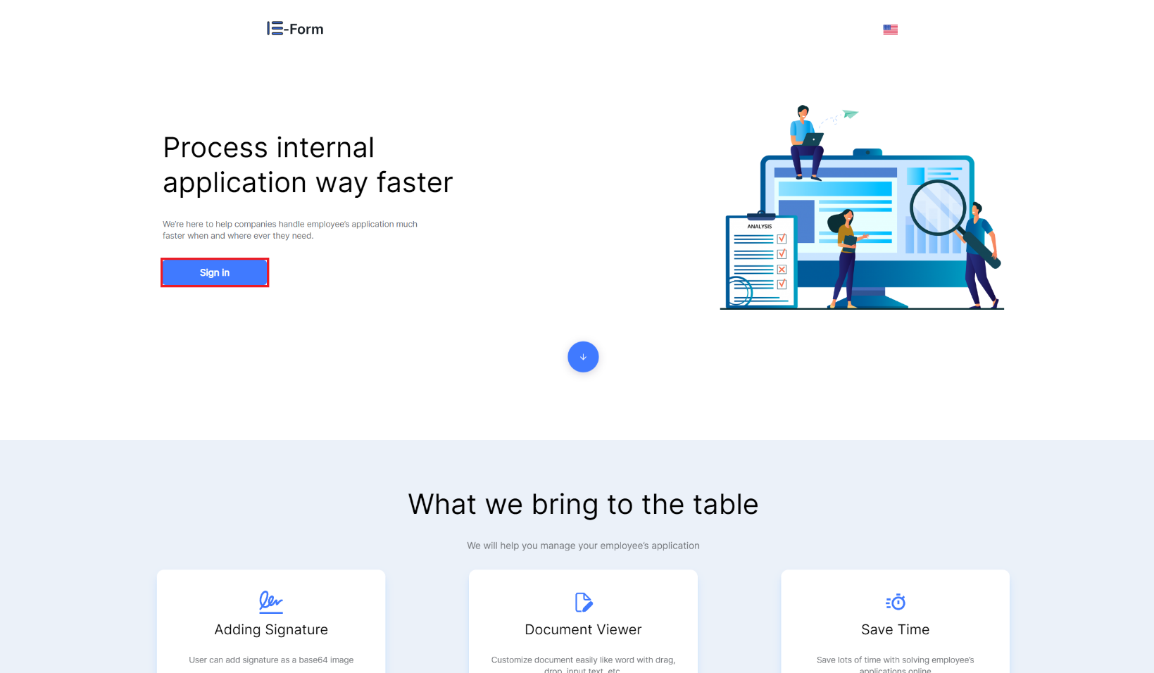

**Figure 1. How to Login**

* 1. 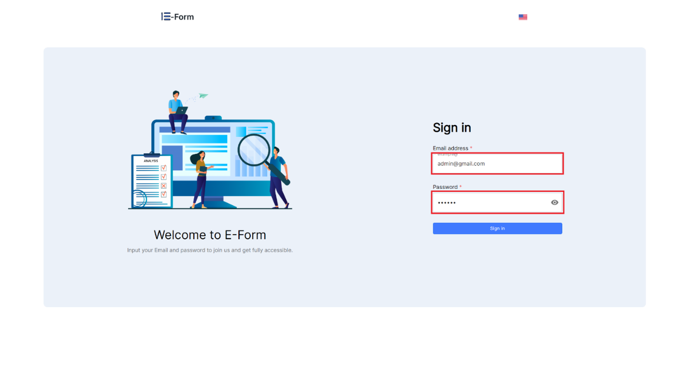At the login interface

**Figure 2. Enter Email and Password**

* 1. 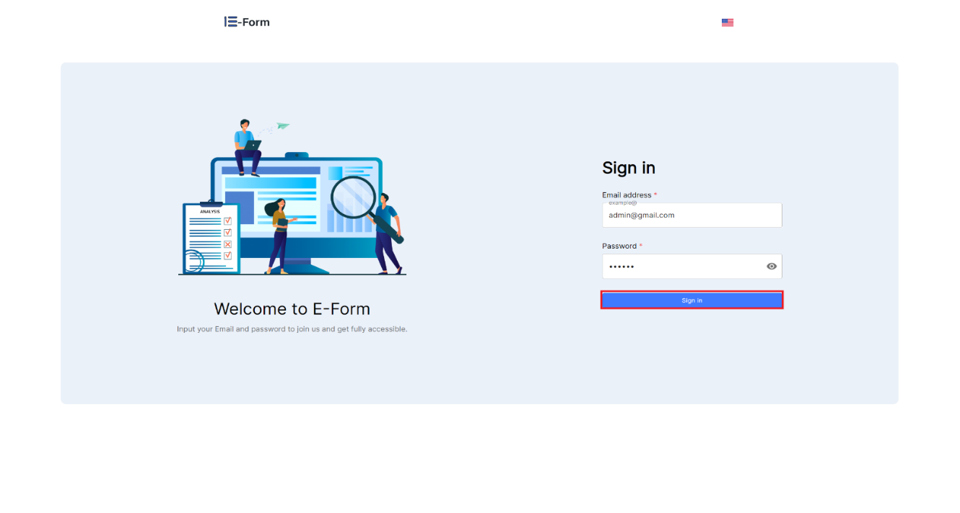Select Sign in after entering Email and password.

**Figure 3. Select Sign in**

* The account management interface is displayed when the user is successfully logged in.

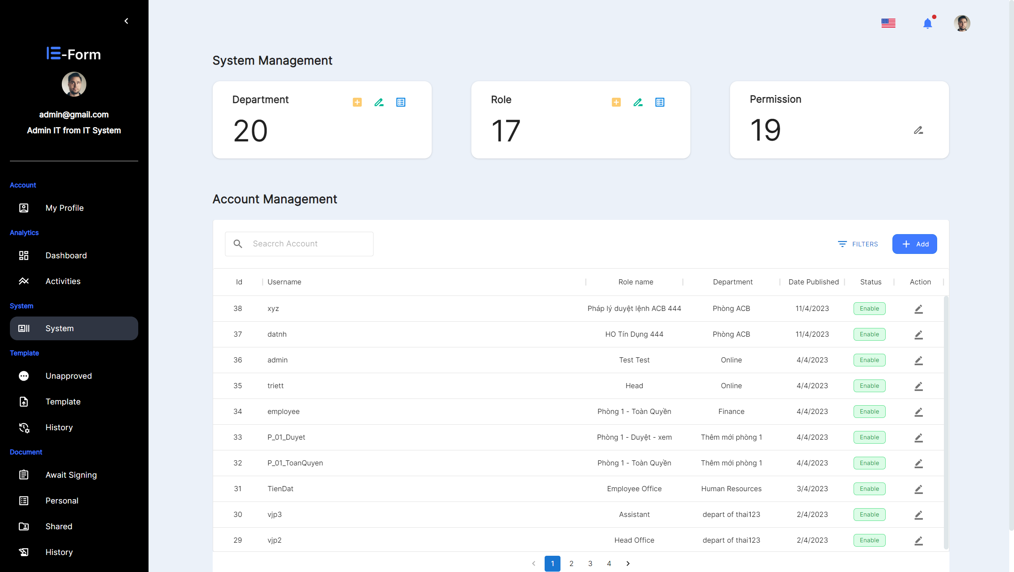

**Figure 4. Logged in successful**

### **Logout with E-Form VLU:**

1. 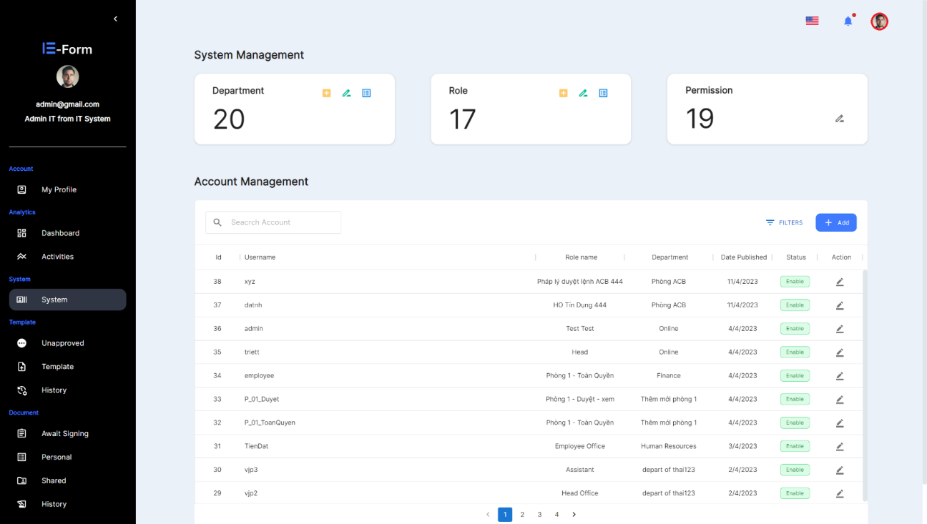Choose your avatar icon at the upper right root of the interface.

**Figure 5. Select icon account action**

1. 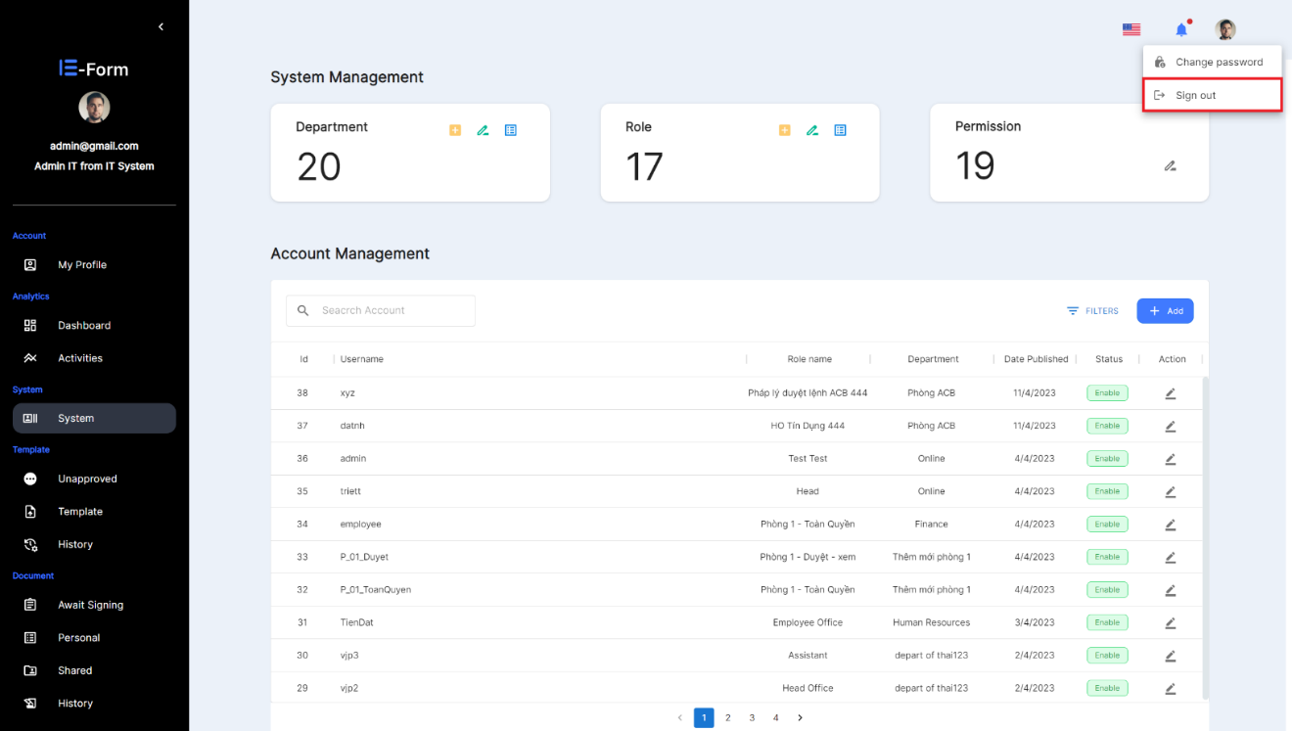Select 

**Figure 6: Sign out action**

* The screen returns to the Home Page after successfully logging out.

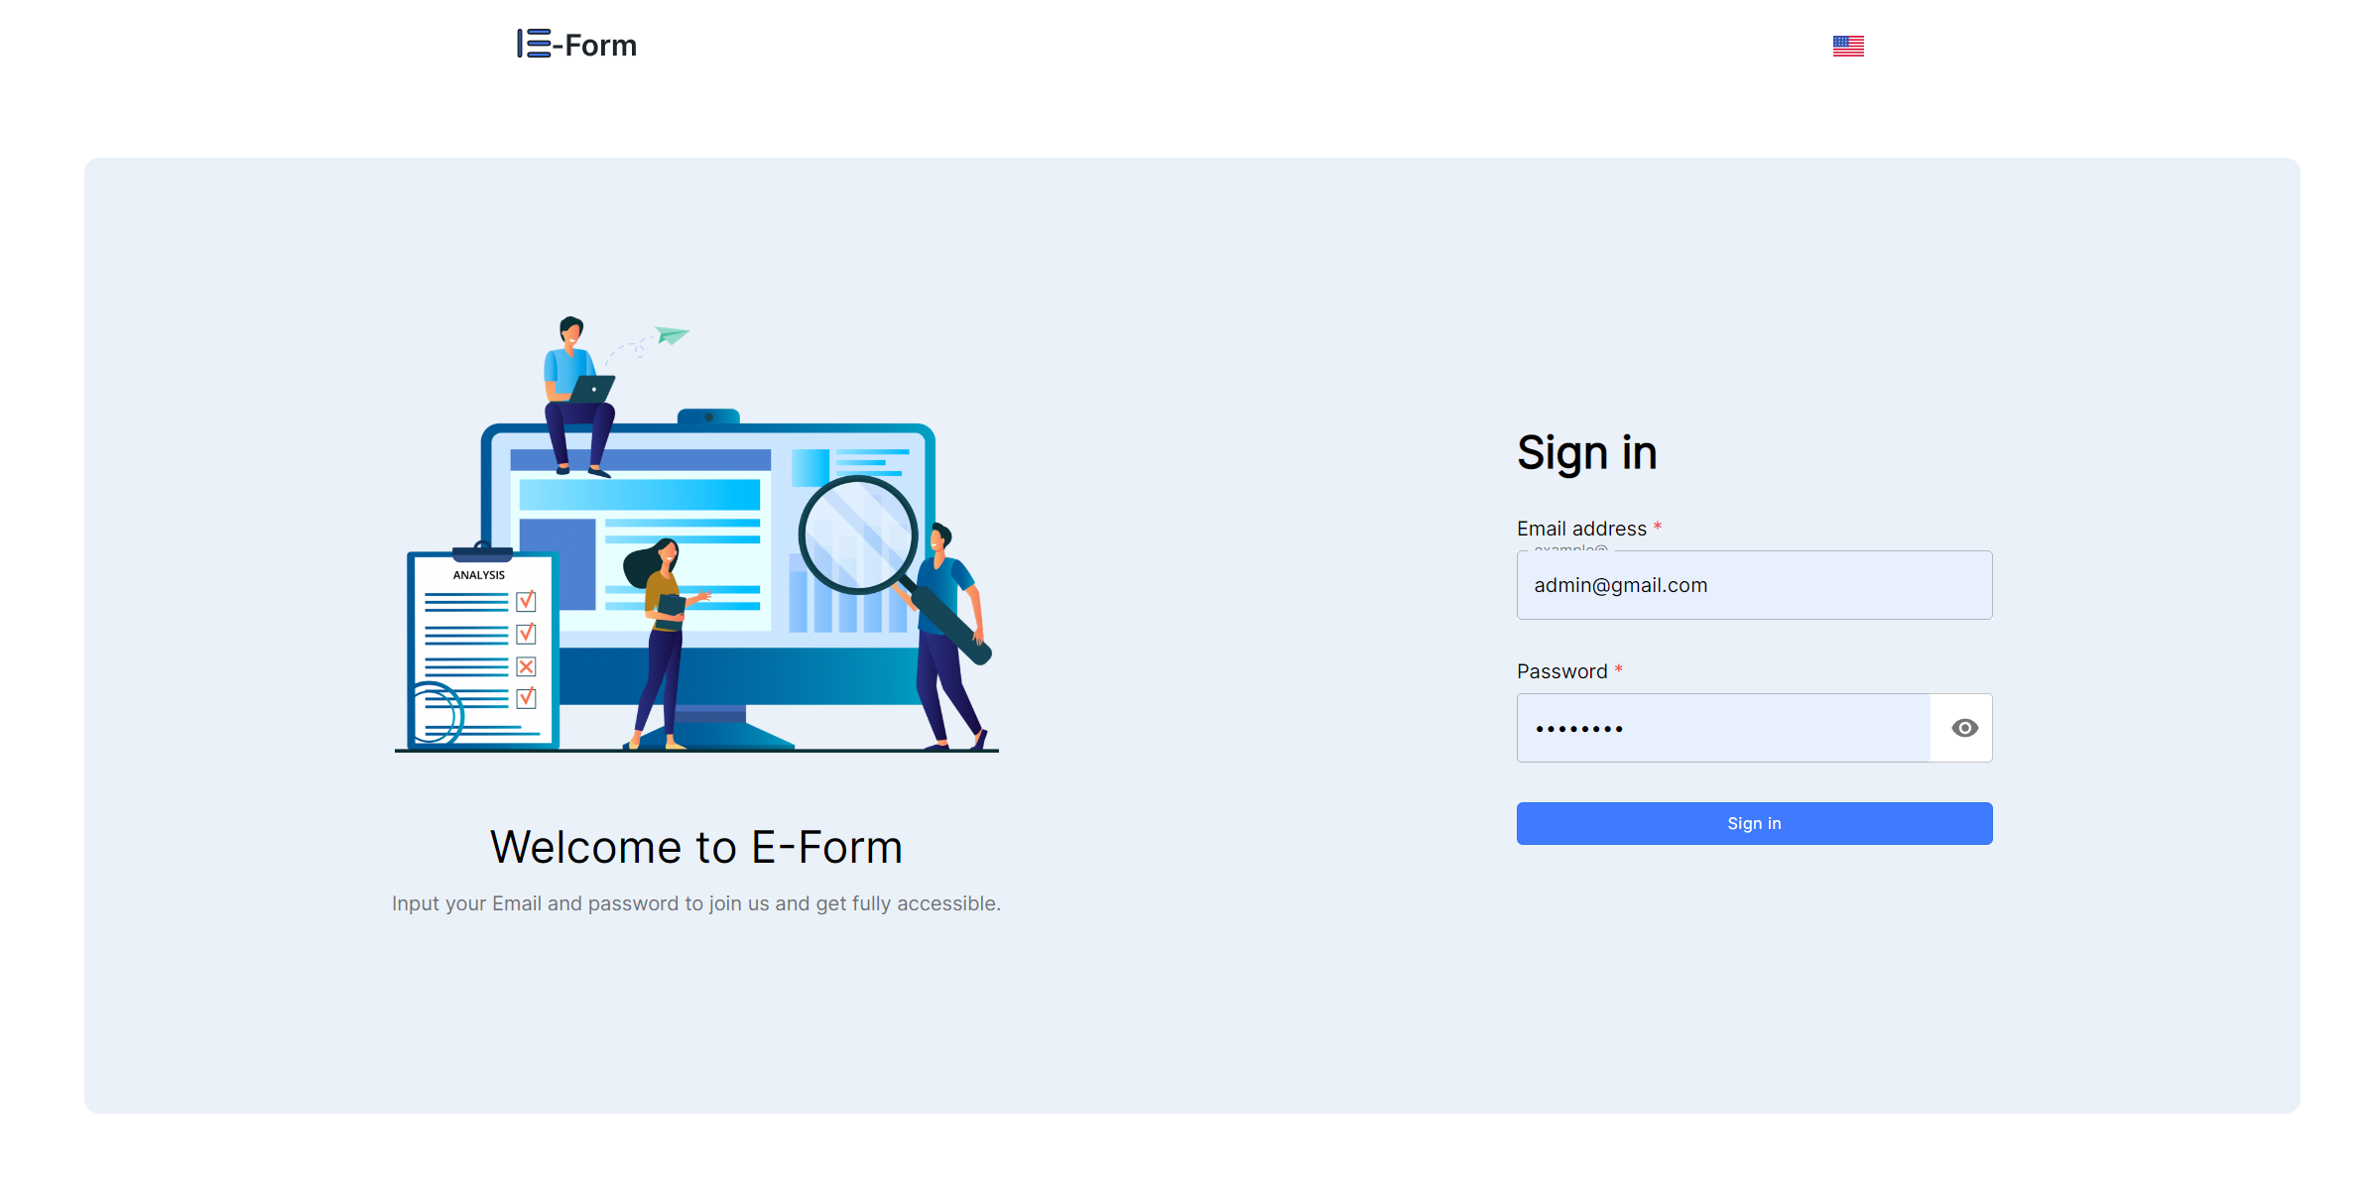

**Figure 7. Home page when successfully logged out**

### **Change language:**

1. At the main interface, select the icon  or 

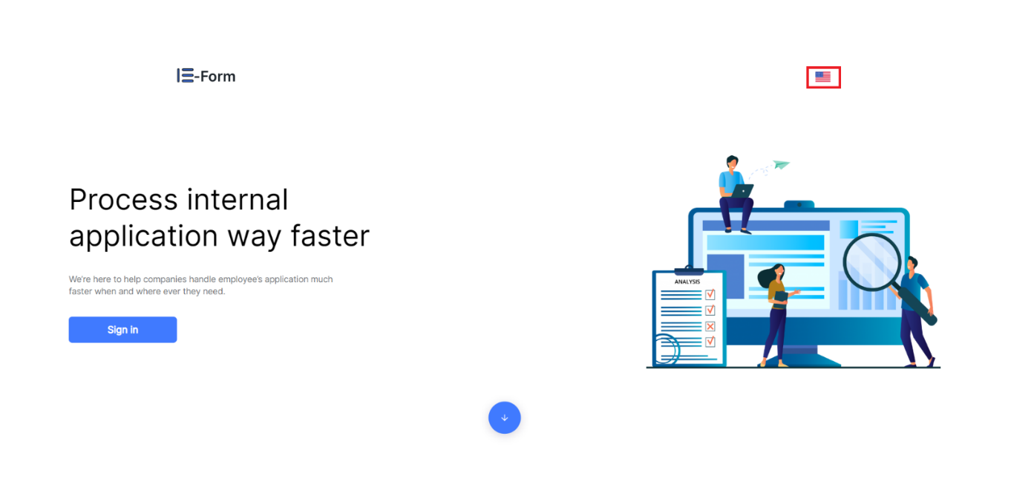**Figure 8. Change language**

1. 1. Select  if you want to switch to Vietnamese interface.

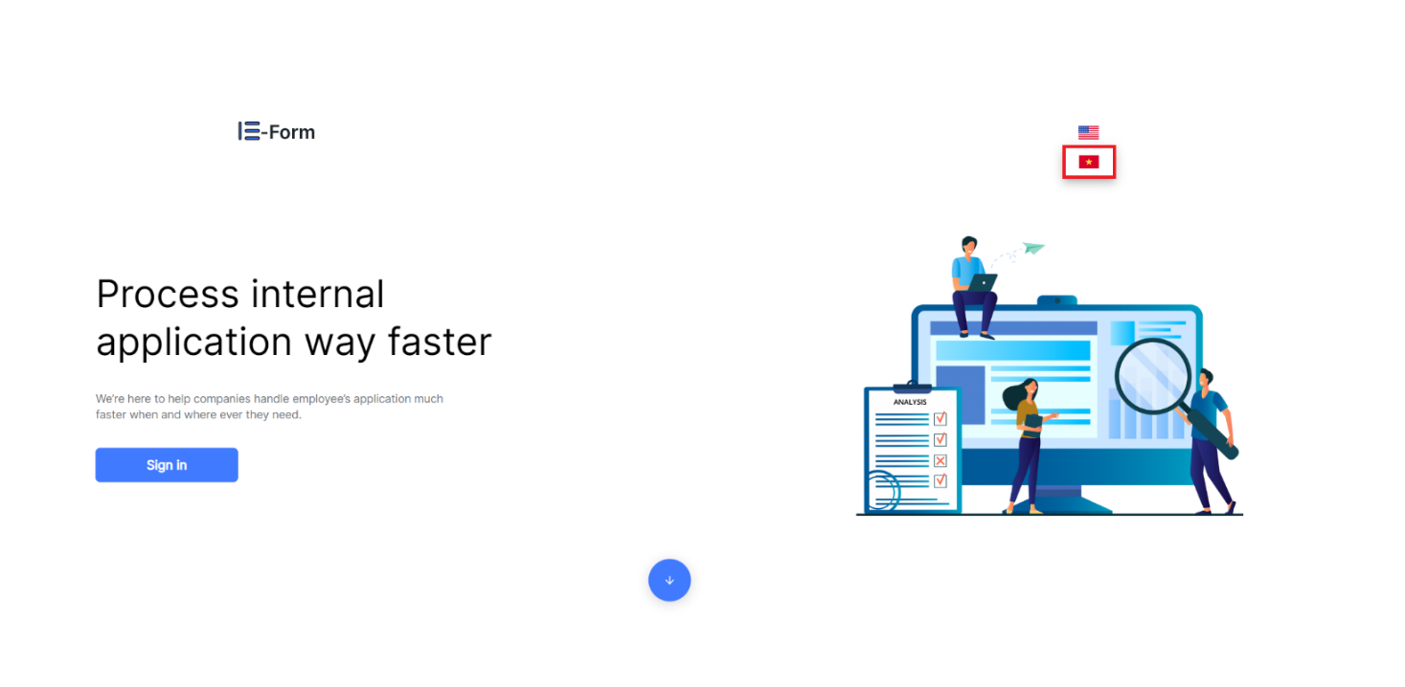

**Figure 9. Change language to Vietnamese**

1. 1. Select  if you want to switch to English interface.

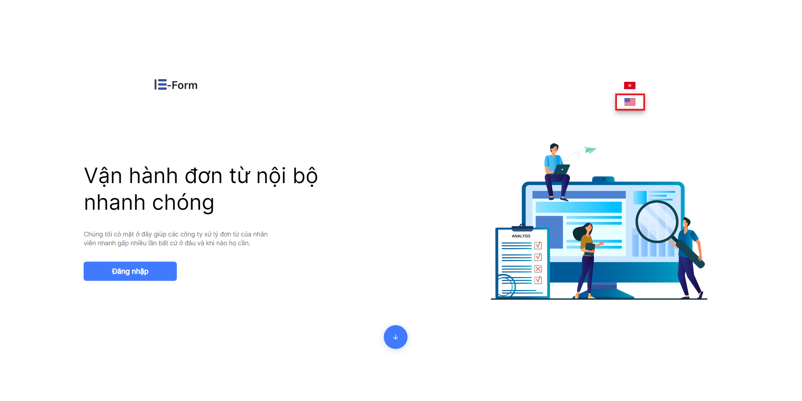

**Figure 10. Change language to English**

## Template Management

### **Create new template:**

1. 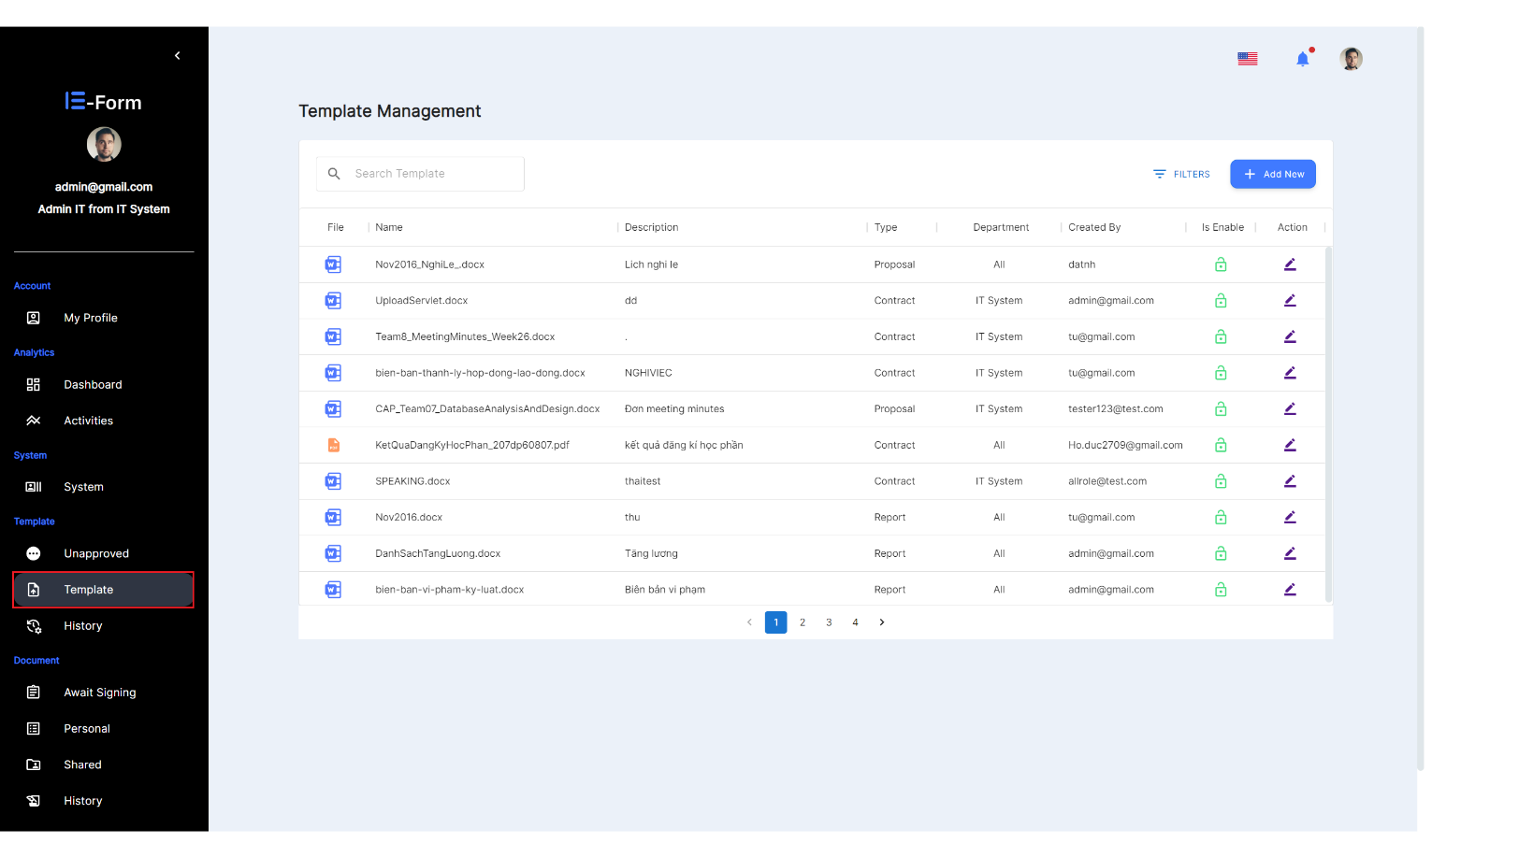Select  on the website interface.

**Figure 11. Select Template for add new template**

1. Select  at the Template interface.

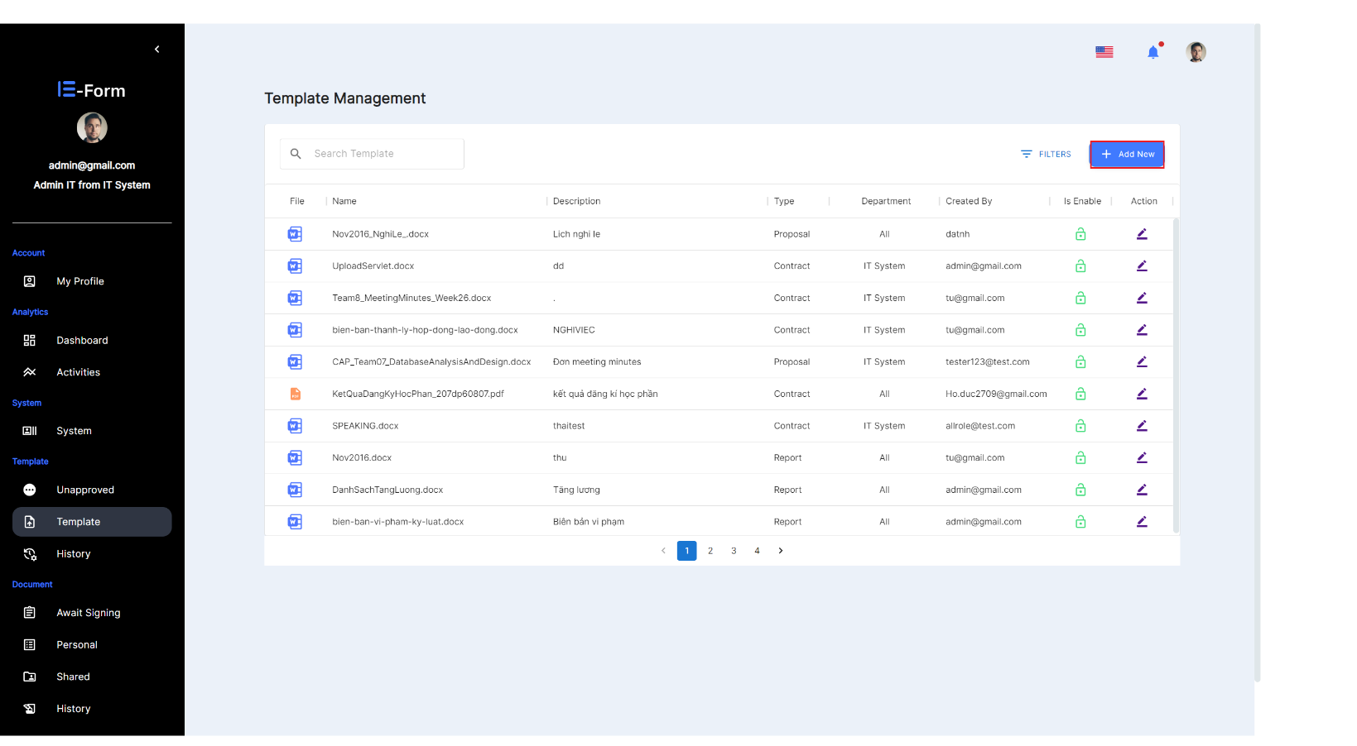

**Figure 12. Select Add new**

1. 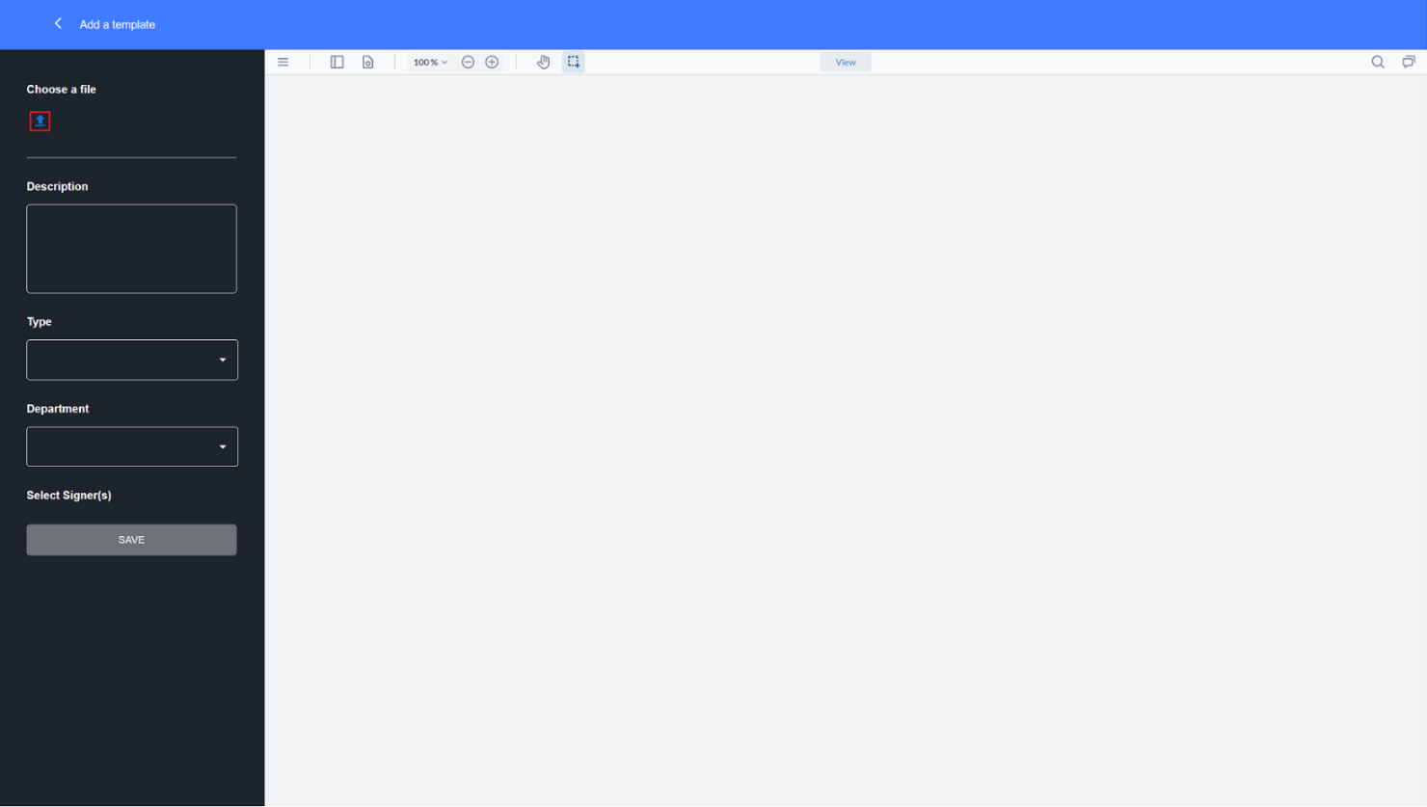At the Add a template interface, select  to upload files from your computer to the website.

**Figure 13. Choose a file**

1. Select the desired file and select open.

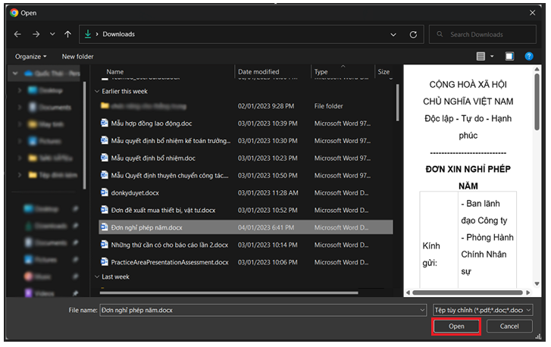

**Figure 14. Select local file**

1. 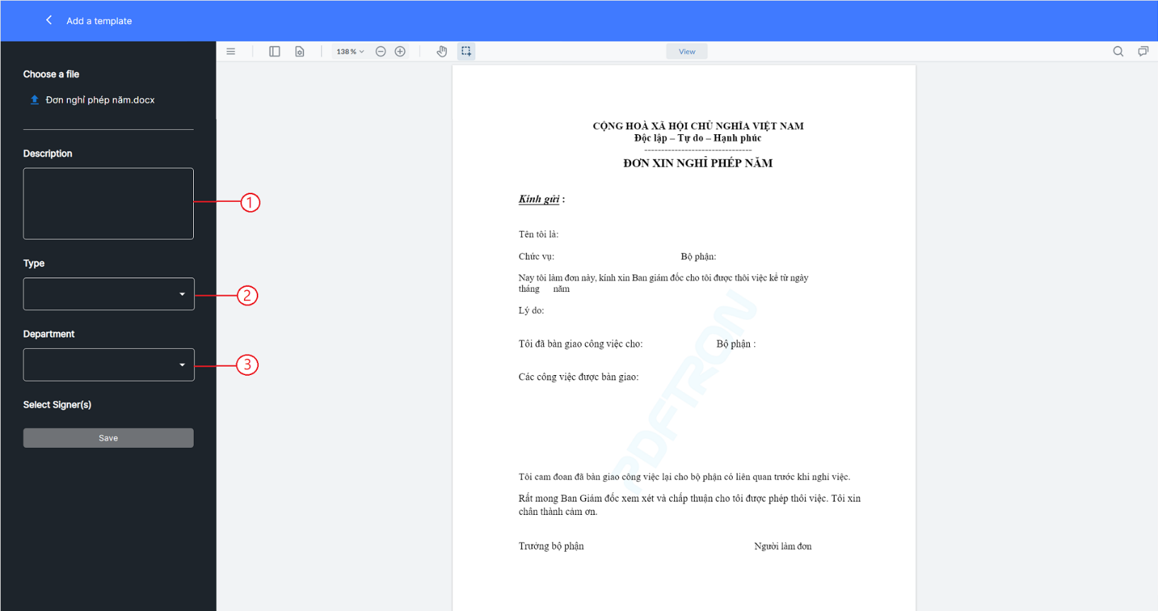At the Add a template interface Enter information for template.

**Figure 15. Enter a description**

: Enter the description of template



: Choose the type of template



: Select the Template Department



1. 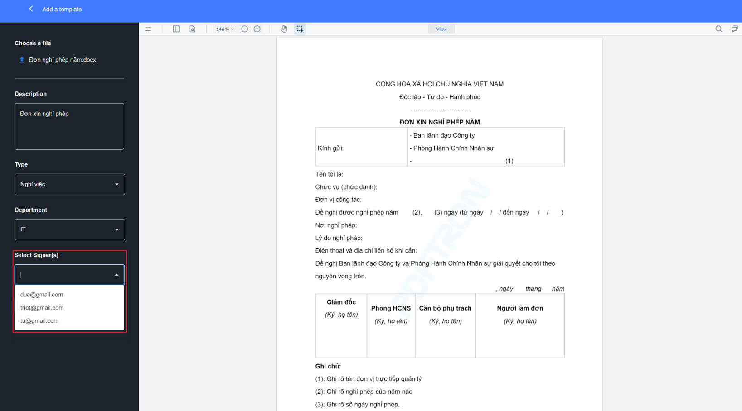Choose a singer.

**Figure 16. Select signer**

1. 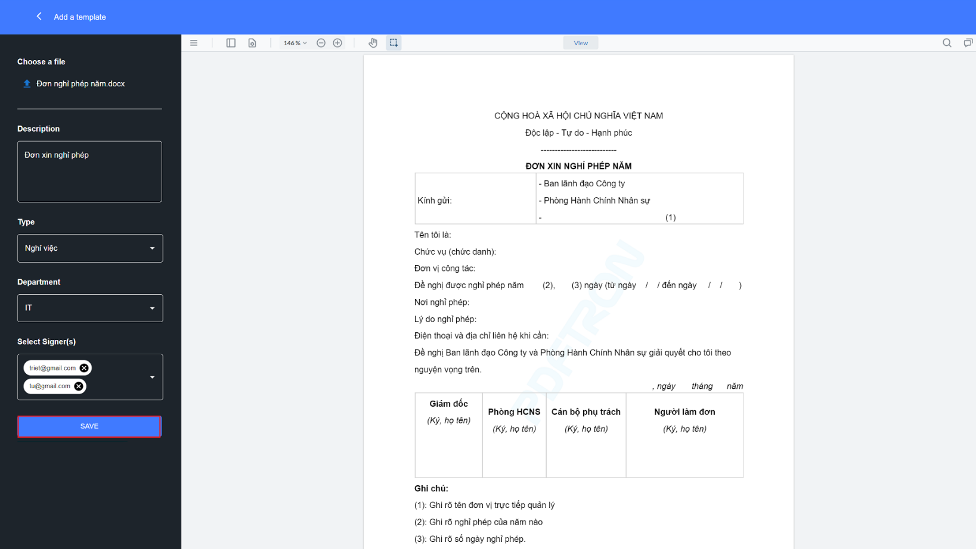Select  to save after checking that the above information is correct and complete.

**Figure 17. Select save for add a template**

1. 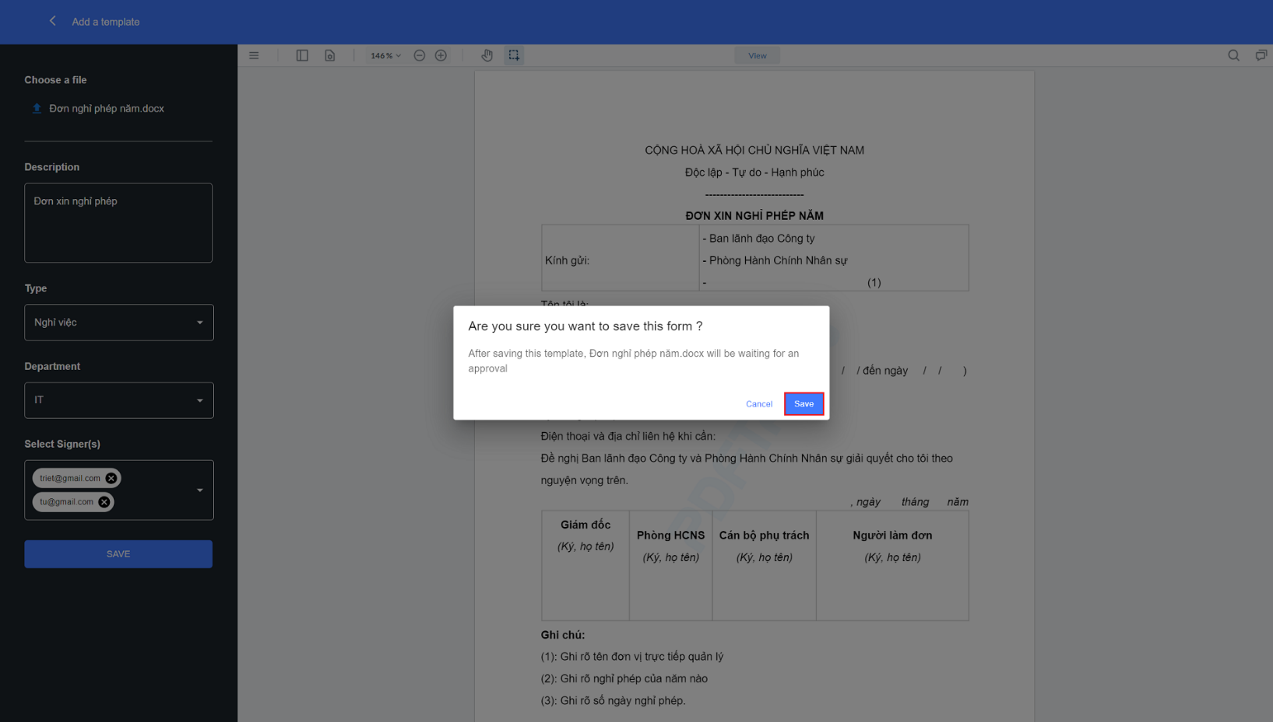Select  to finish.

**Figure 18. Save to finish for add a template**

1. 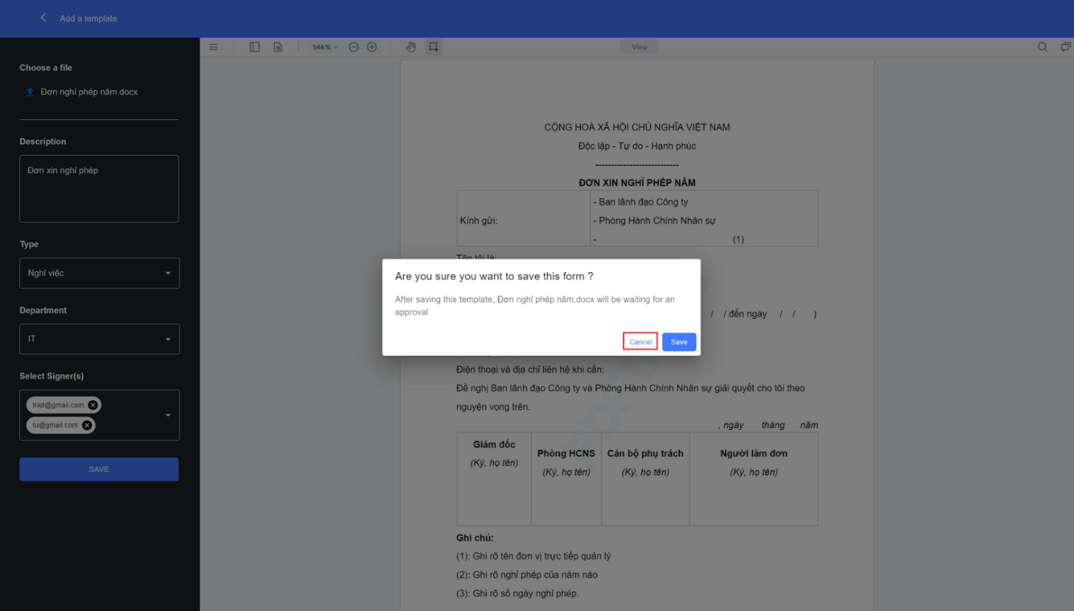Select  to cancel and continue editing information.

**Figure 19. Select cancel and continue editing information**

* Notification when creating a successful template.

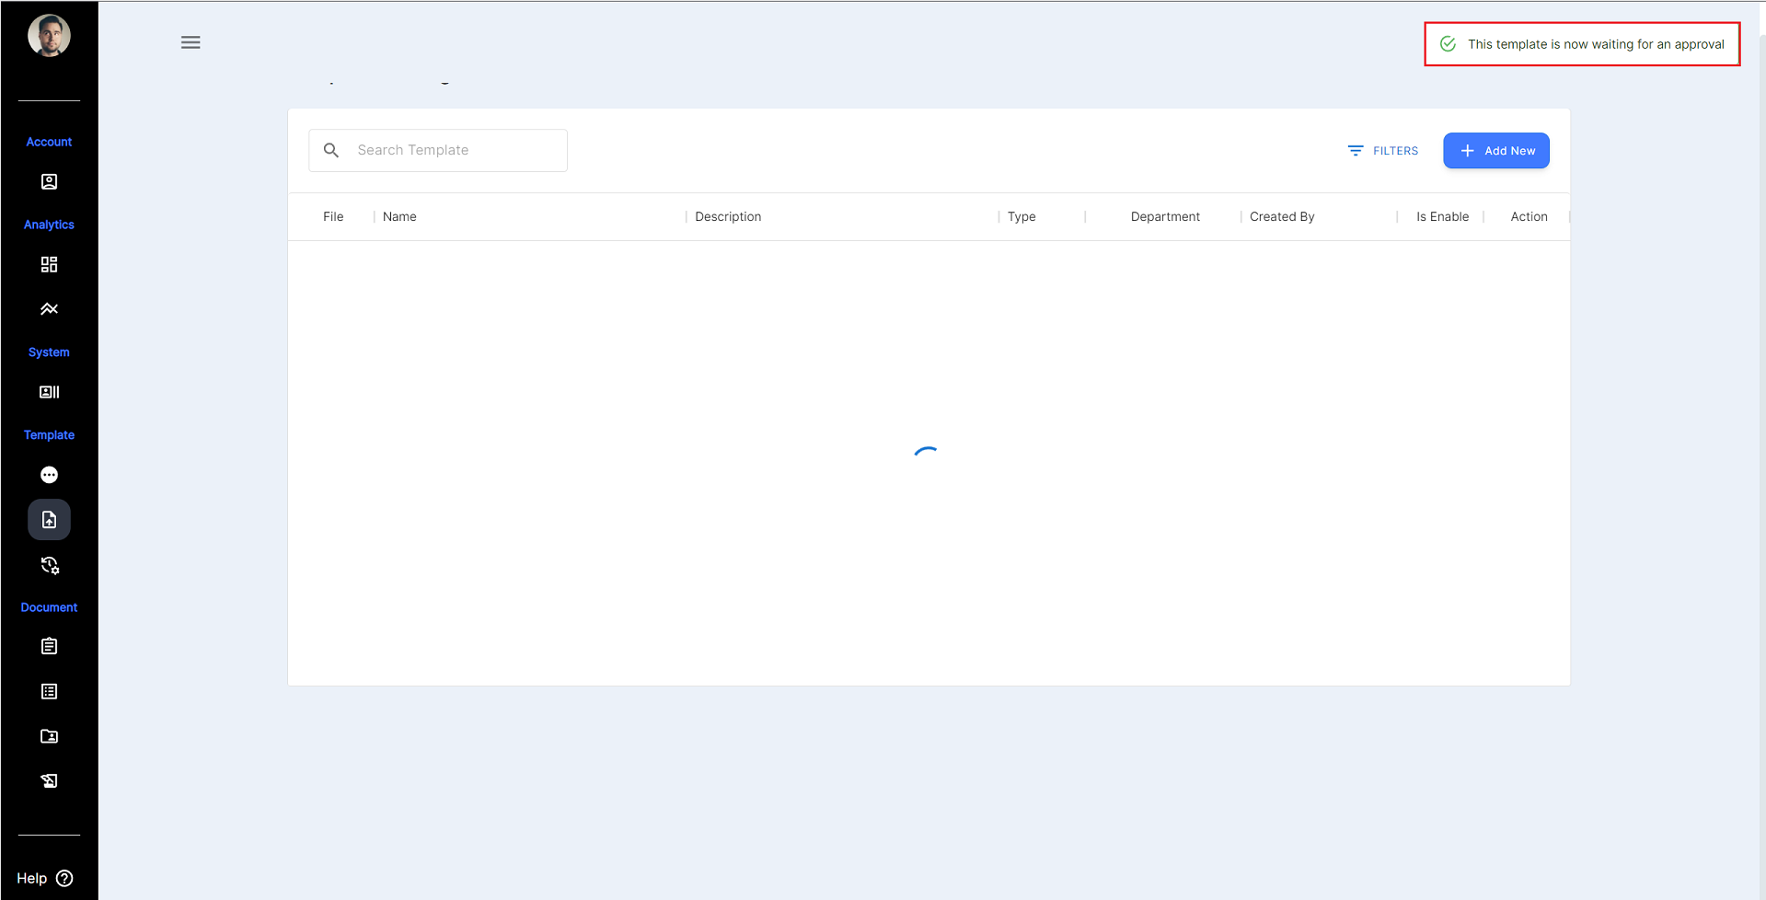

**Figure 20. Notification of successful template creation**

### **View history of created templates:**

1. Select  on the website interface.

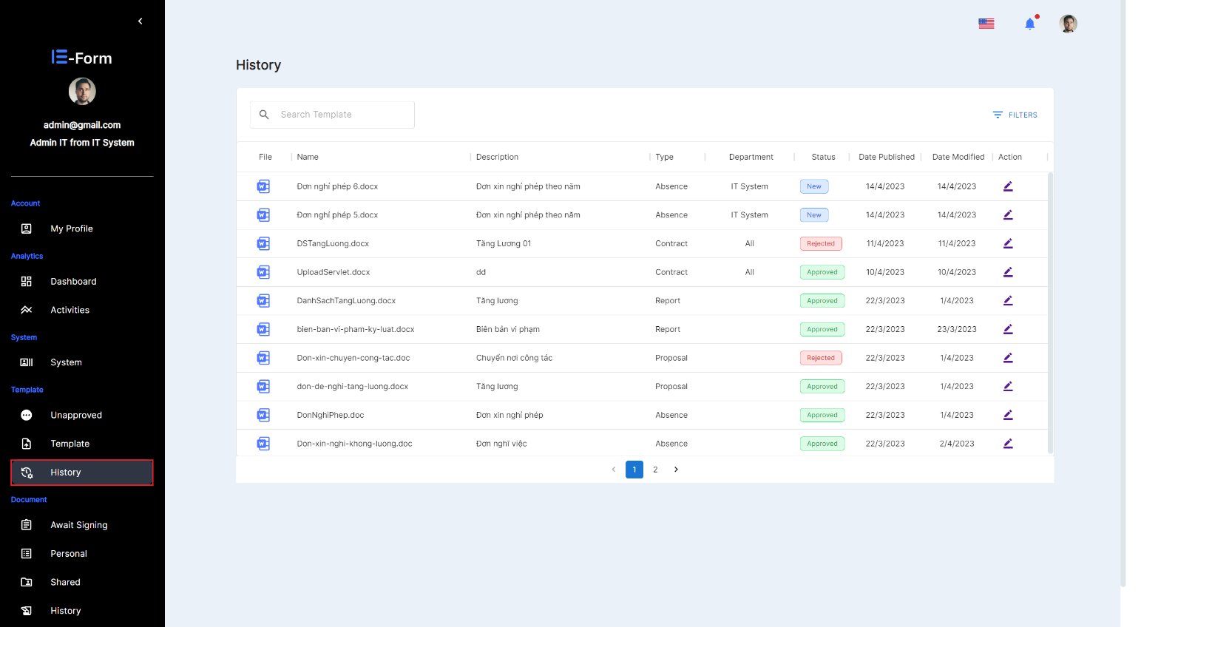

**Figure 21. Select history for view history**

1. Select the ****icon in the Action column.

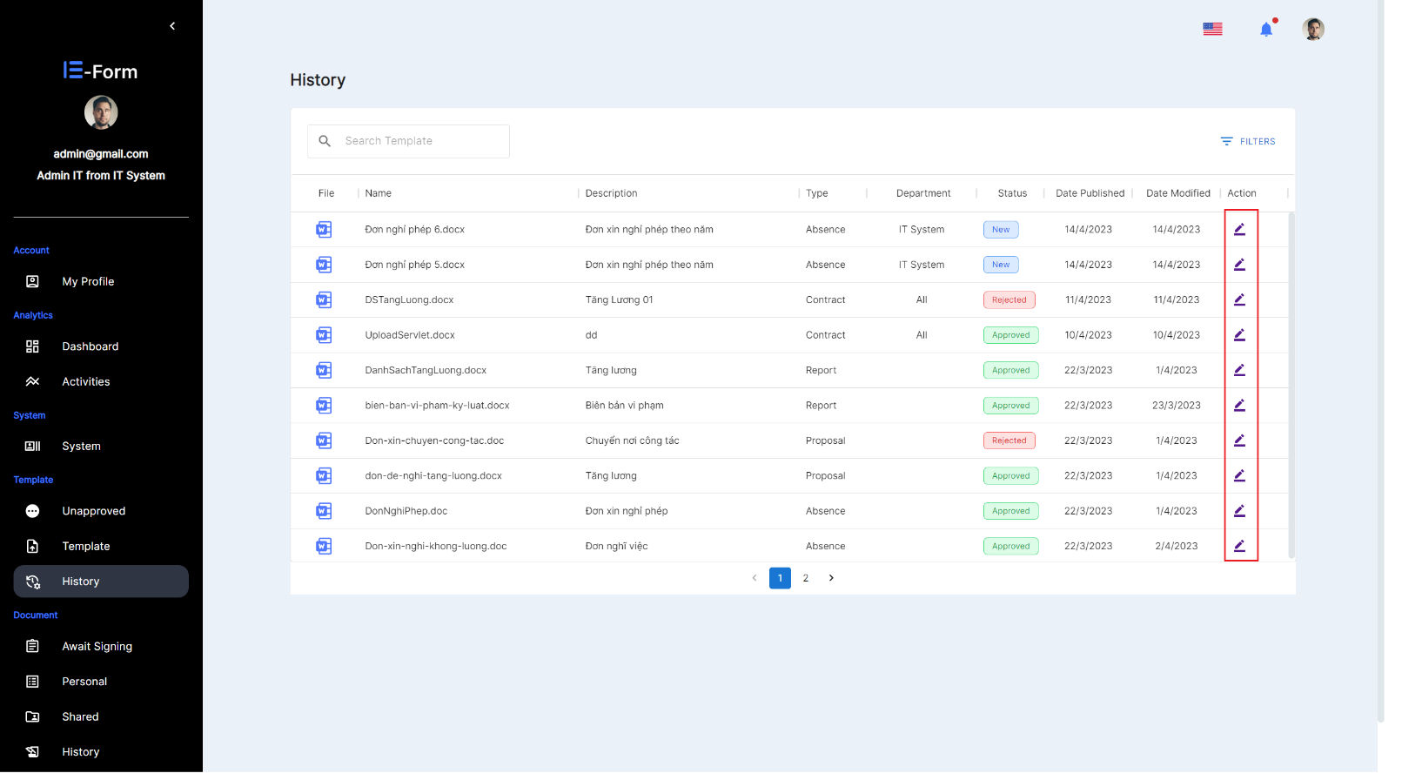

**Figure 22. Select Template to view in history**

* 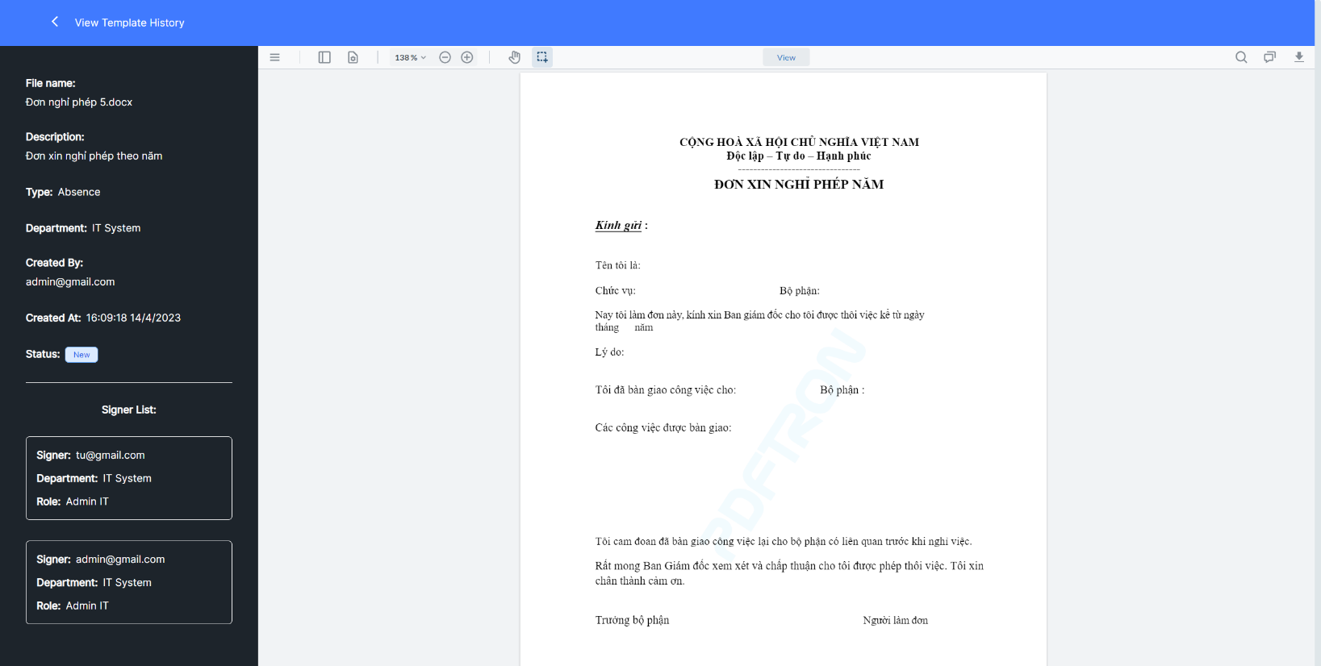View the history of the template was successful.

**Figure 23. View the history of the template was successful**

### **View and search history template:**

1. Select  on the website interface.



**Figure 24. Select history for view and search template**

1. Enter keywords in the search box.

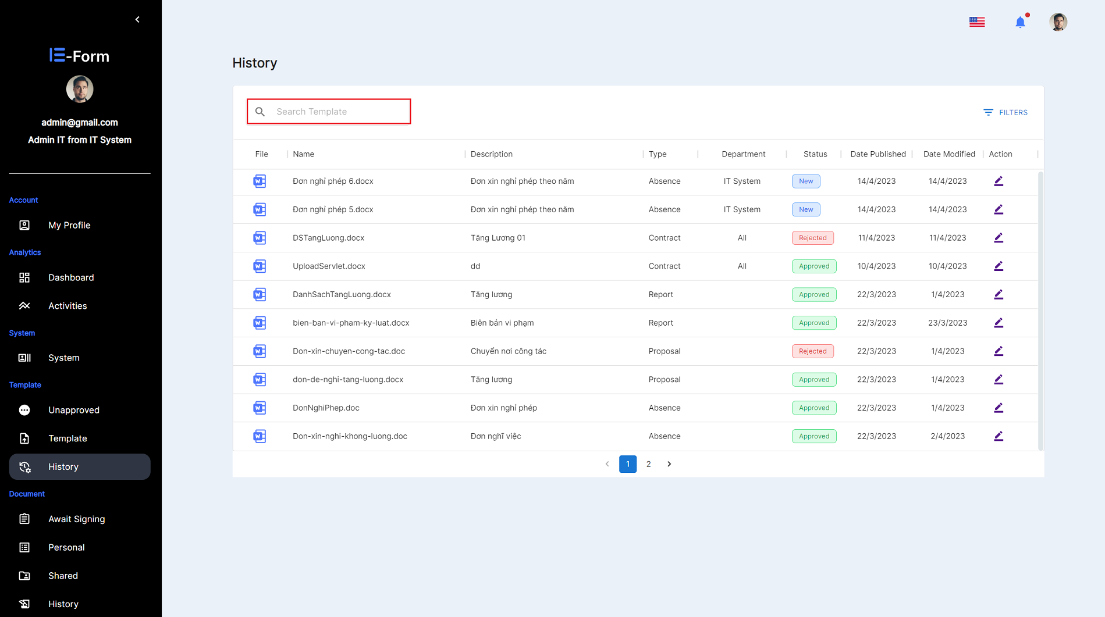

**Figure 25. Enter the template search keyword in the history**

* After entering a keyword, the system will automatically search for templates with names related to that character.

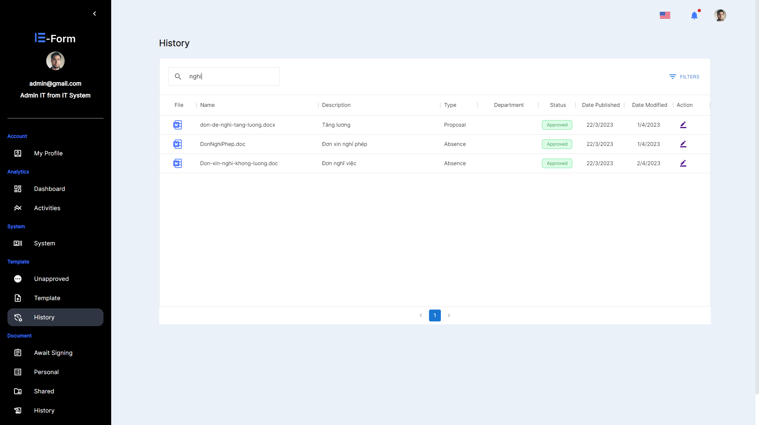

**Figure 26. Finding success in history**

### **Enable/Disable template.**

1. Select  on the website interface.



**Figure 27. Change the state of the template**

1. In the Is Enable column select icon  to disable the template, select icon  to enable the template.

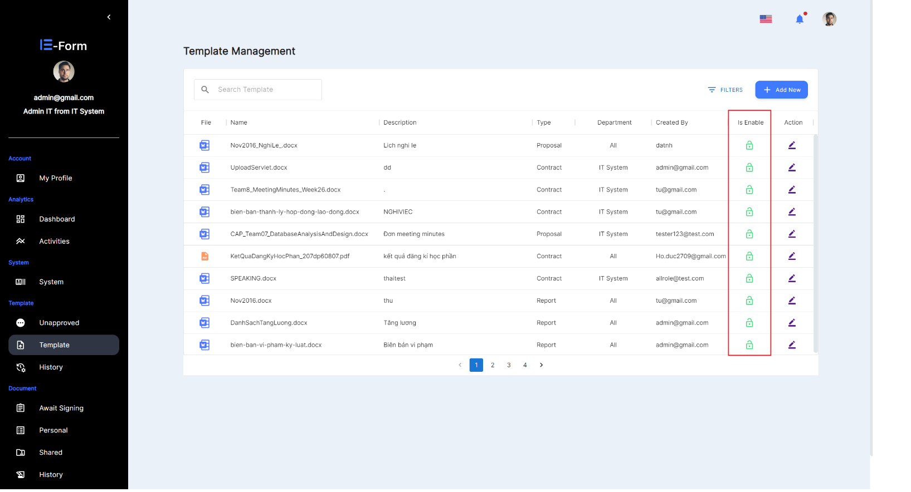

**Figure 28. Make a state change of the template**

* Success message when changing template state from enable to disable and vice versa.

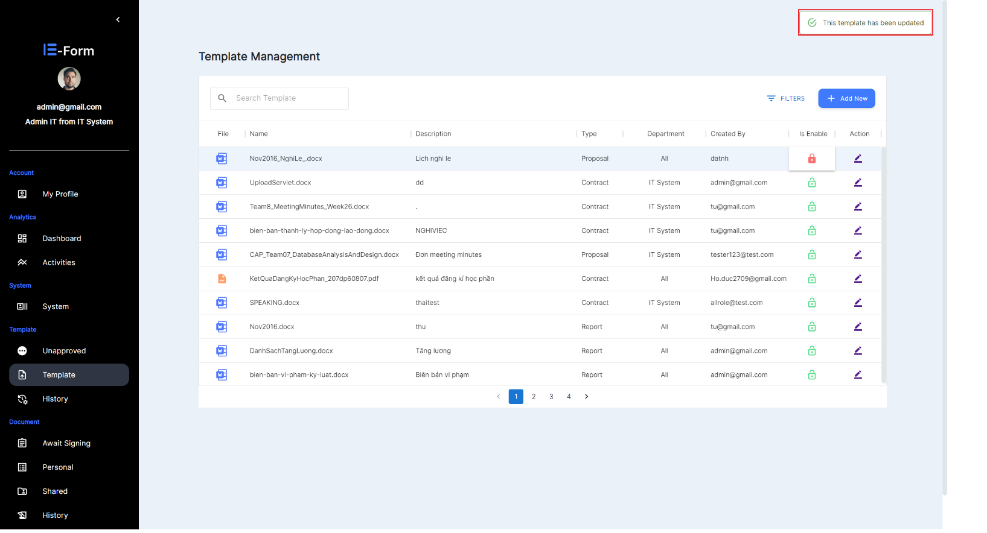

**Figure 29. Notification of successful template status update**

### **Approved template**

1. Select  on the website interface.

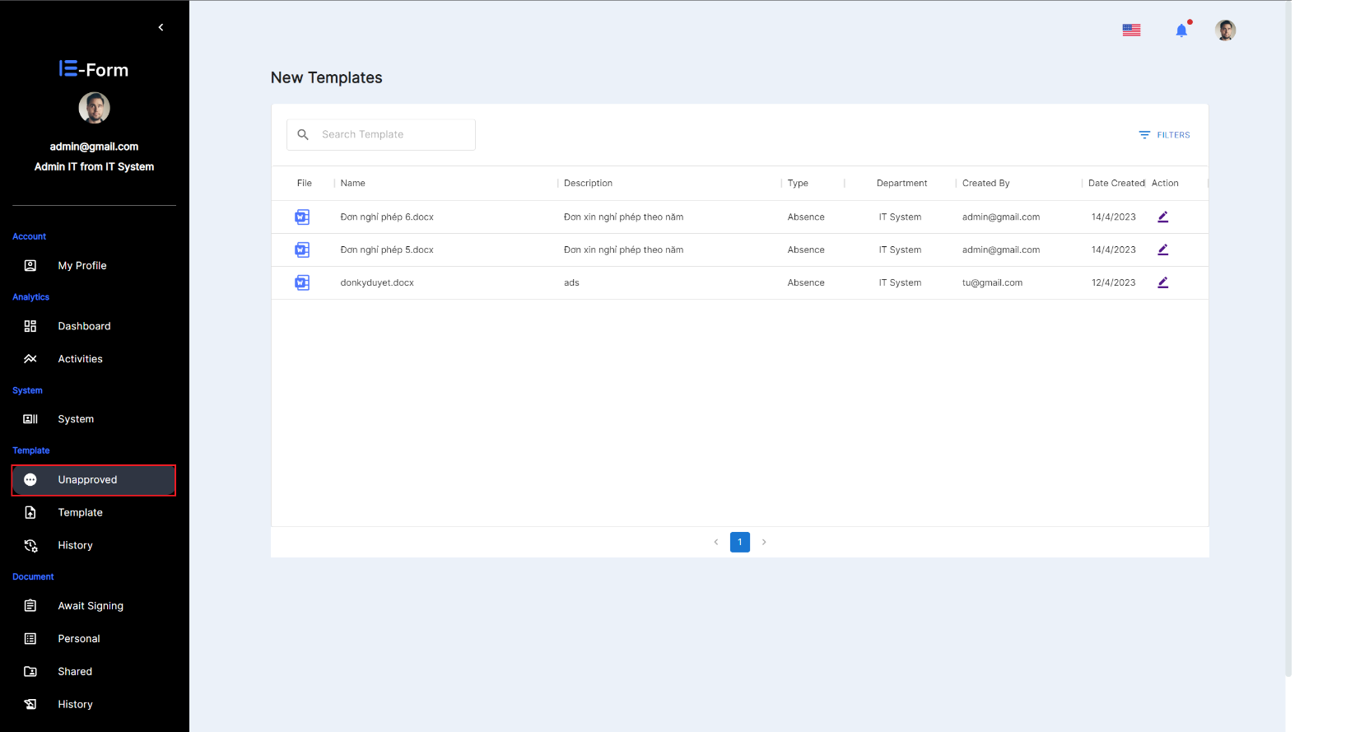

**Figure 30. Open the list of unapproved templates**

1. In the Actions column, select  icon of the template you want to approve.

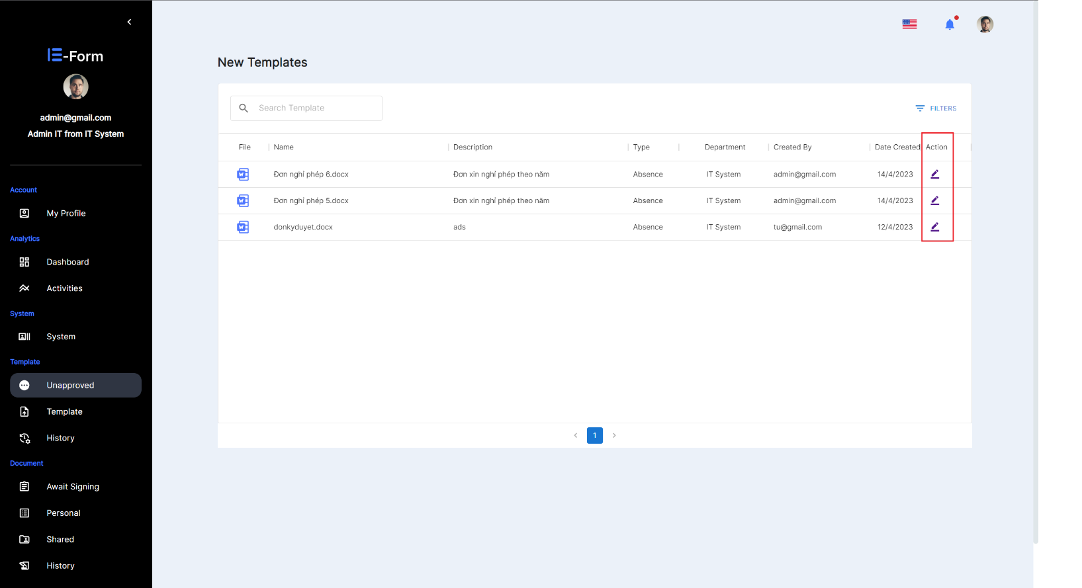

**Figure 31. Take action on unapproved list of templates**

When the status is  and the user select , the system will save that template.

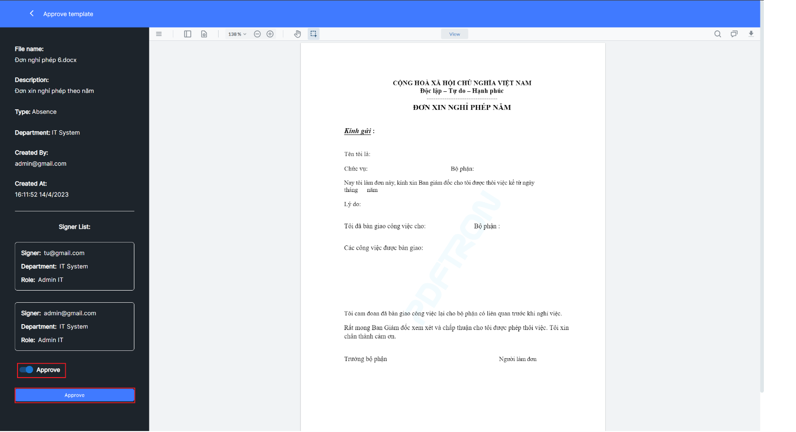

**Figure 32. Perform template browsing**

When the status is , the user must enter the reason in the Reason box (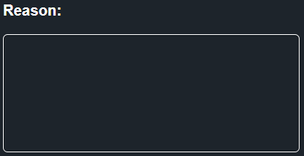), the system will display the  button for the user to click, then the template will be rejected.

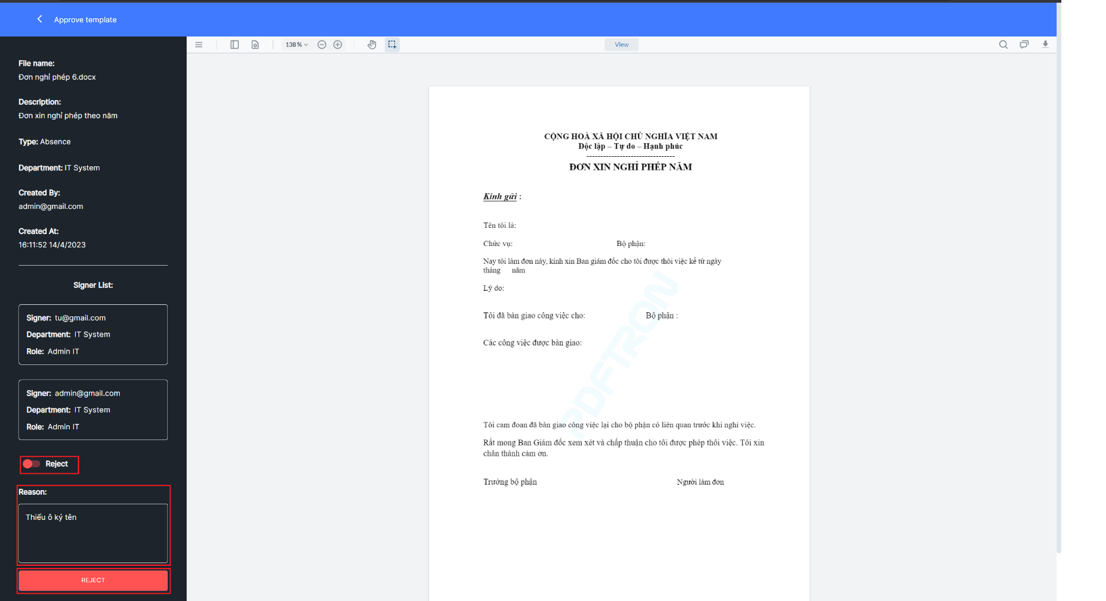

**Figure 33. Implement template rejection**

* 1. With the status is Approve, select  to approve the template or select to cancel and return to the approval process.

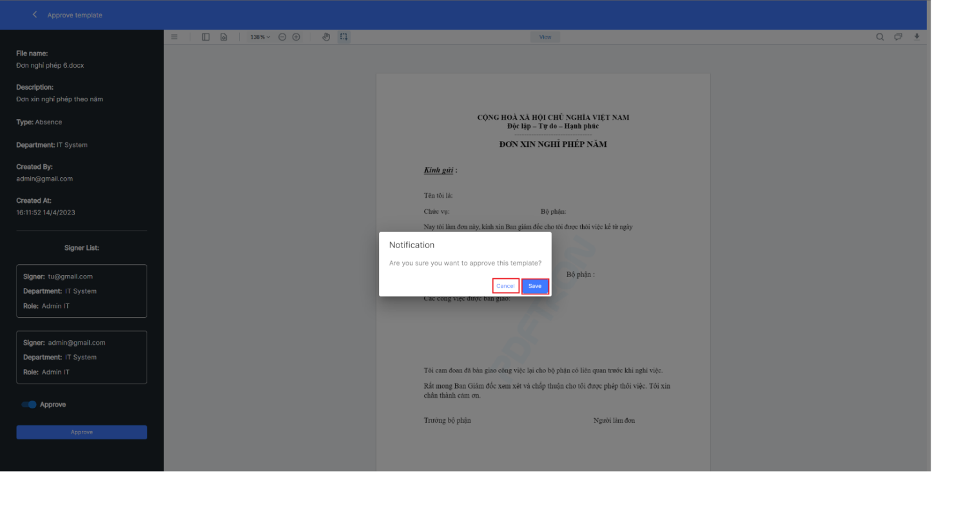

**Figure 34. Action notification when choosing template approval**

* 1. With the status is Reject, select  to reject the template or select to cancel and return to the approval process.

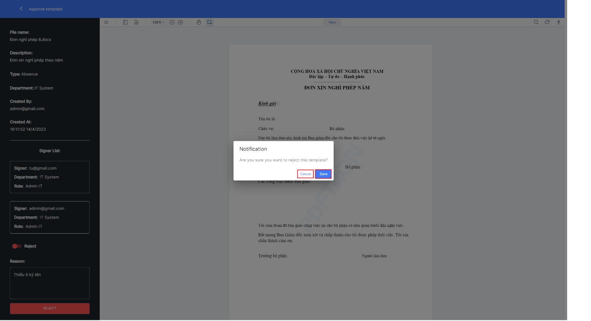

**Figure 35. Action notification when choosing to reject a template**

* Notification when template has been approved successfully.

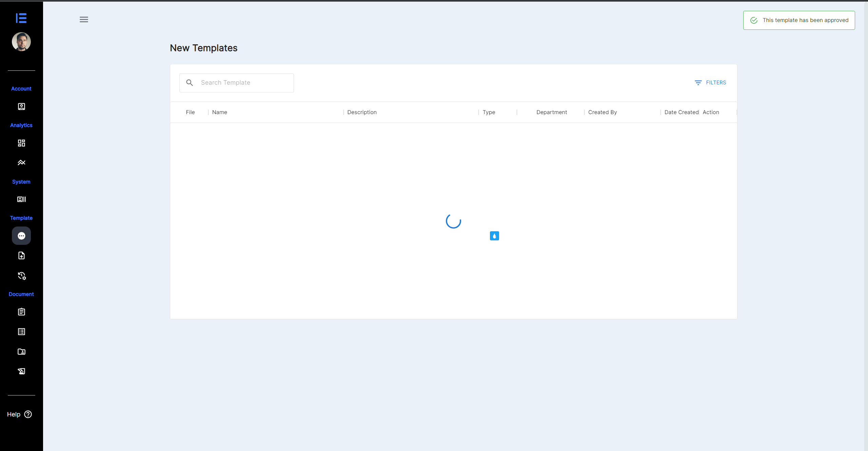

**Figure 36. Notification of successful template approval**

* Notification when template is successfully rejected.

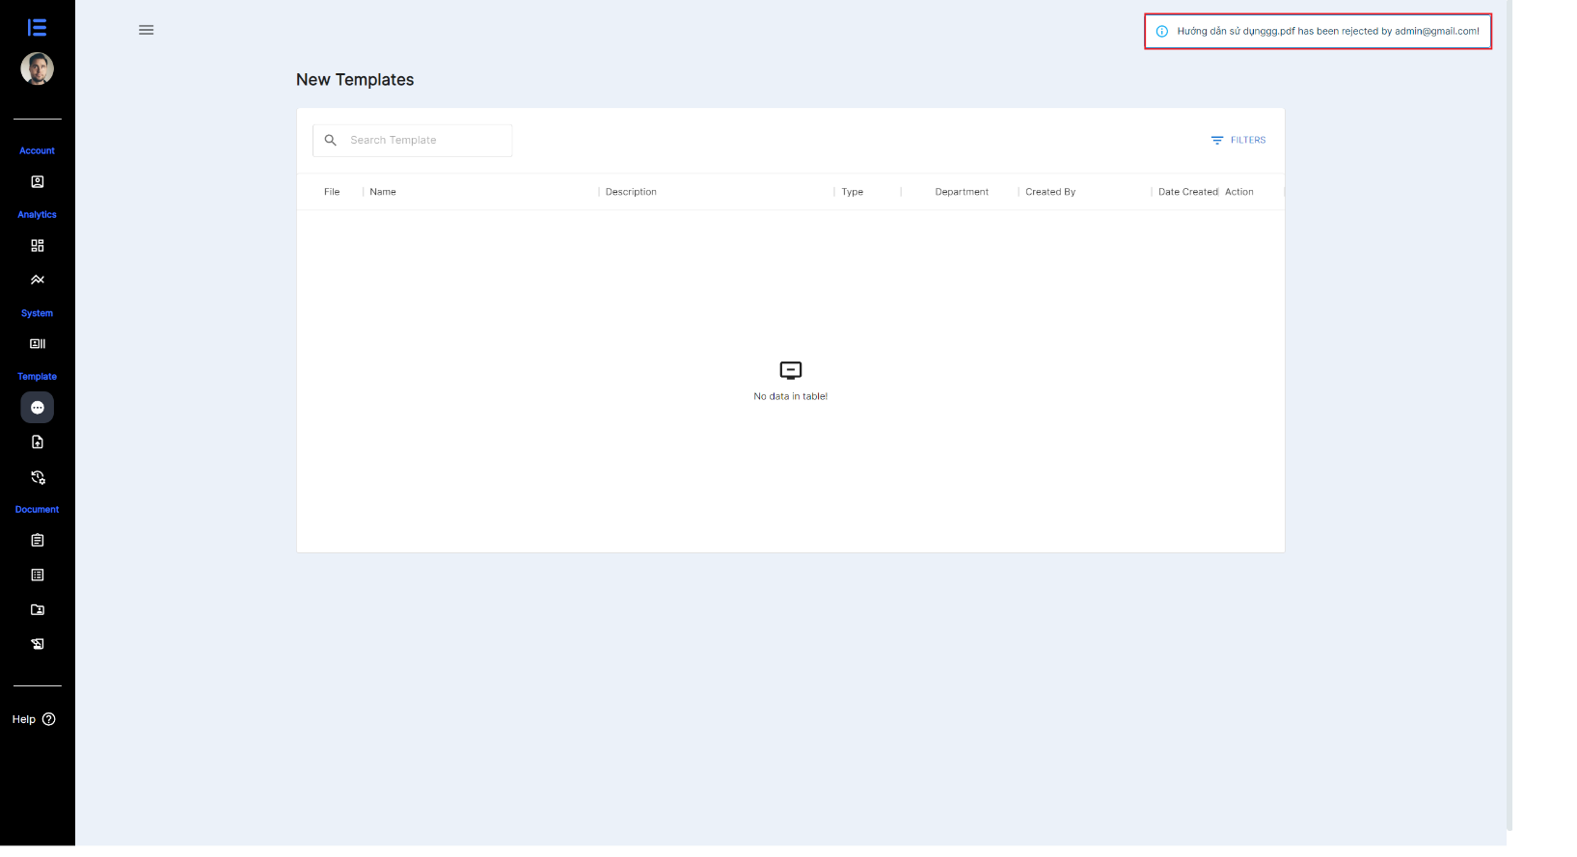

**Figure 37. Notice of successful template rejection**

### **View and search unapproved template.**

1. Select  on the website interface.

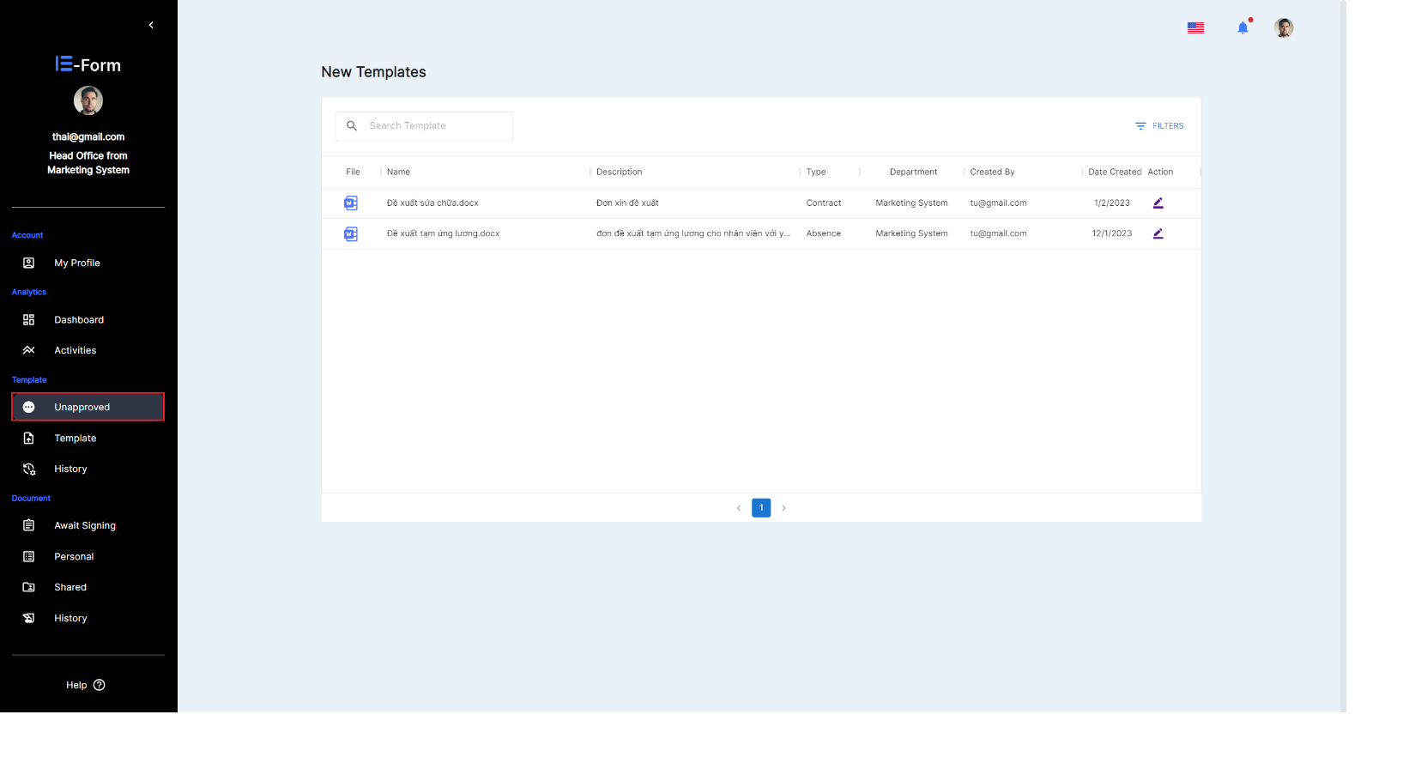

**Figure 38. View and search unapproved template**

1. Enter keywords in the search box.

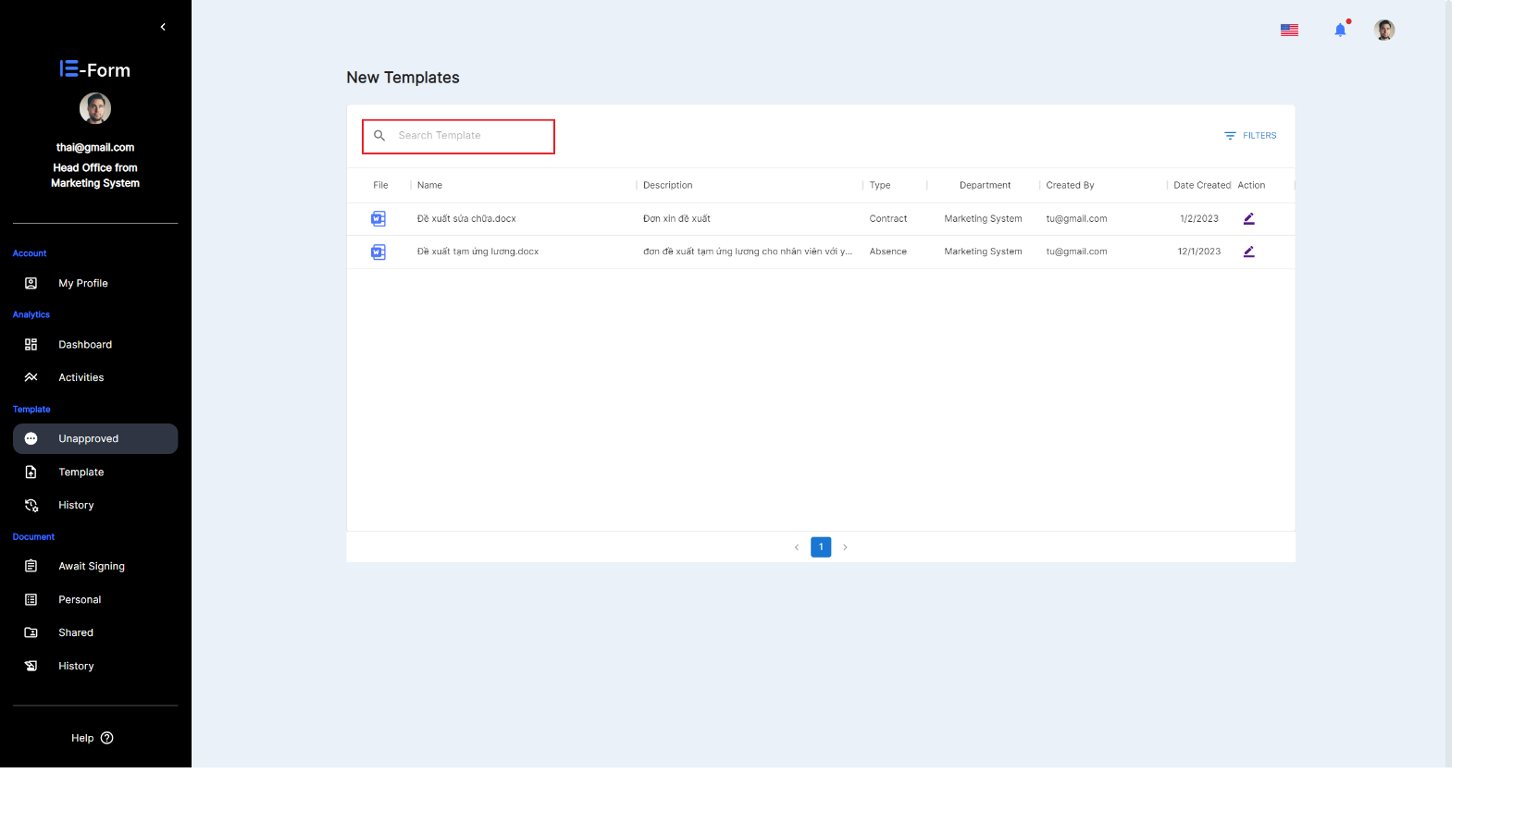

**Figure 39. Enter keywords in unapproved**

* After entering a keyword, the system will automatically search for templates with names related to that character.

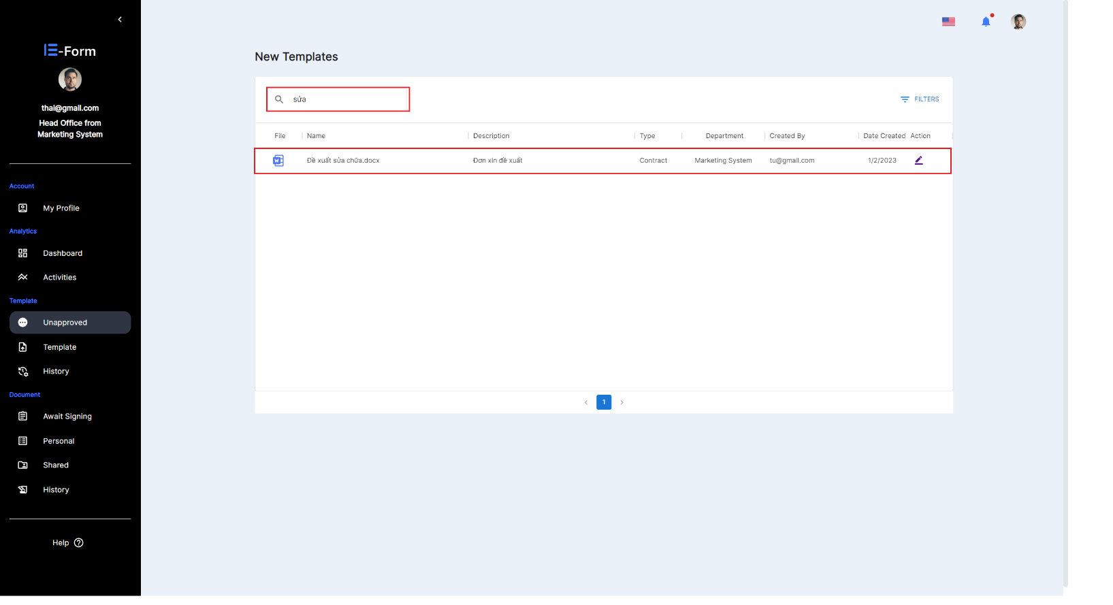

**Figure 40. Showing unapproved listings after searching**

### **Create await signing document.**

1. Select  on the website interface.

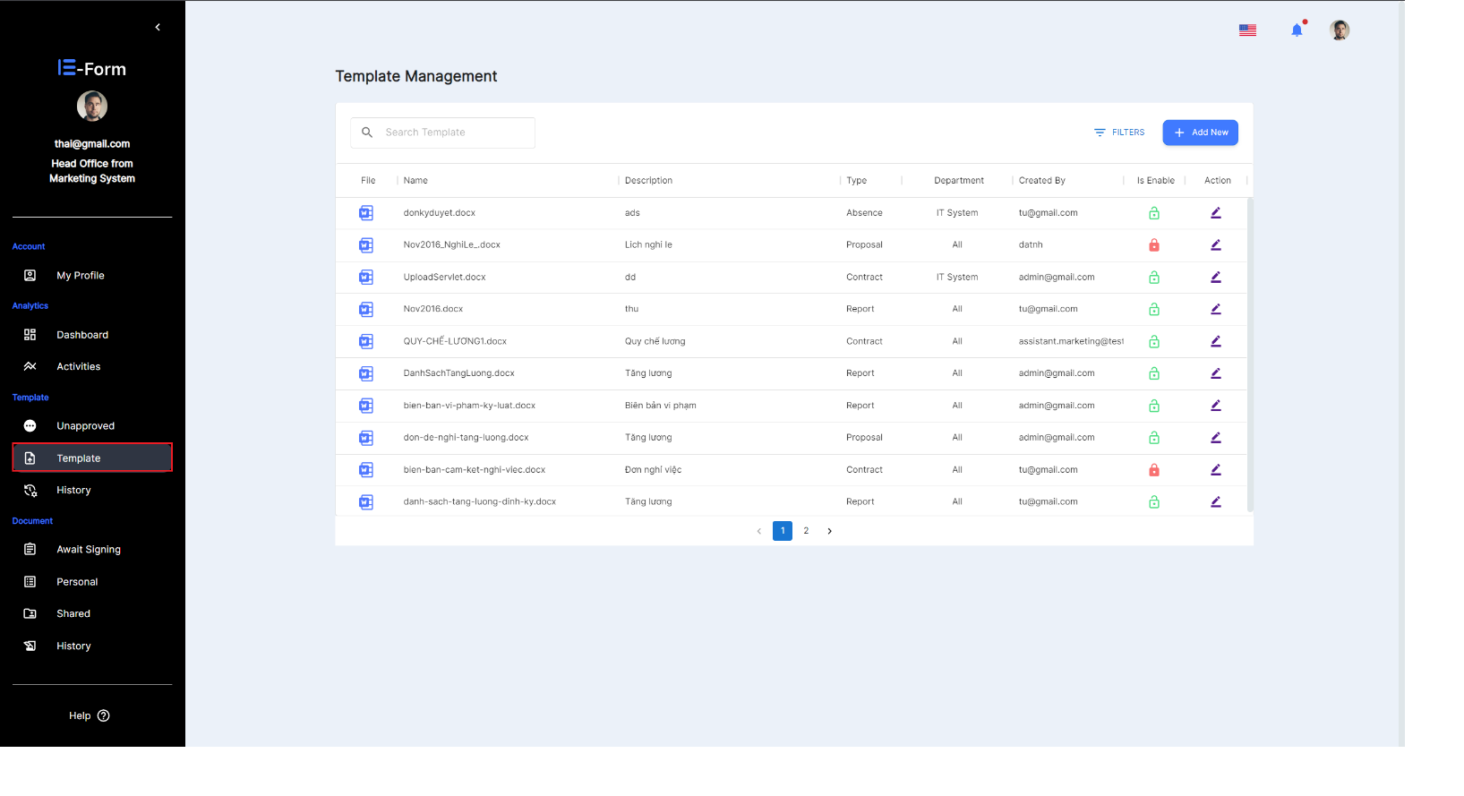

**Figure 41. Create await signing document**

1. In the Action column, select icon  of the template that the user wants to use

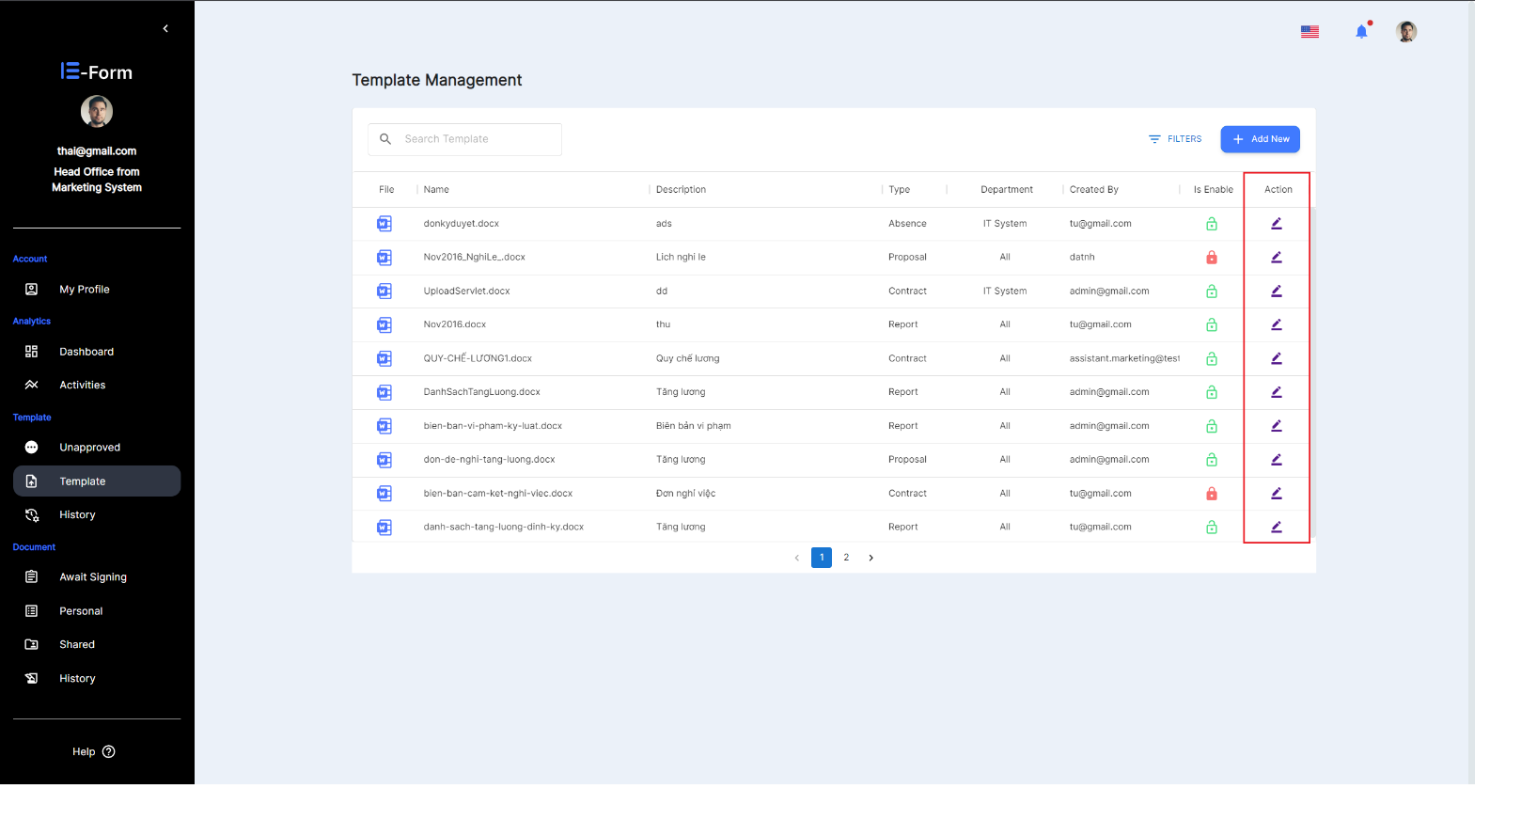

**Figure 42. Use the form to go through the signing process**

1. At create await signing document interface, users will use this toolbar to fill in information and complete the document.

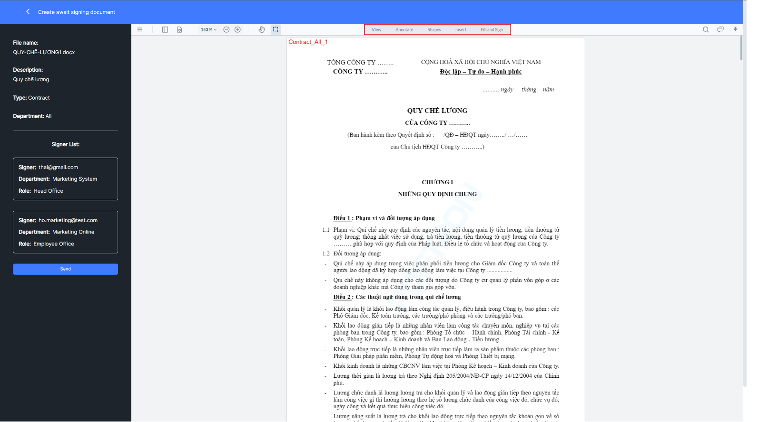

**Figure 43. Design document**

1. After designing the document, select  to send the document to the signer for approval.

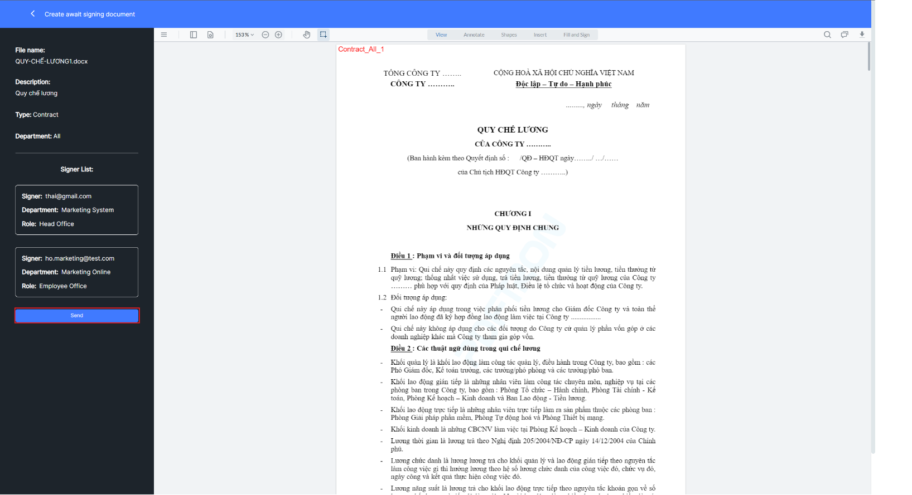

**Figure 44. Send template**

* Successful notification when the document is sent to the signatories for approval.

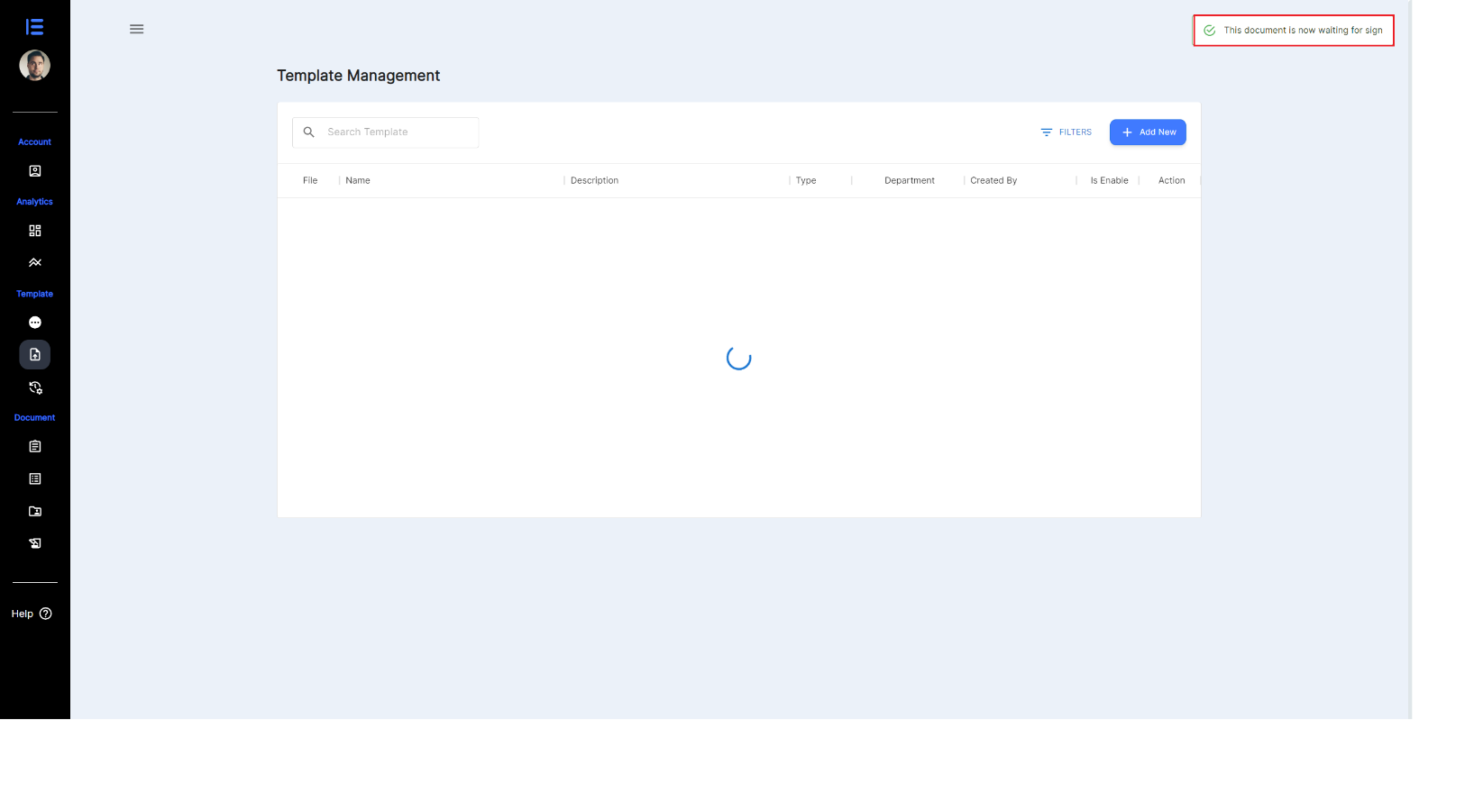

**Figure 45. Template send successfully**

### **View and search template.**

1. Select  on the website interface.



**Figure 46. View and search template**

1. Enter keywords in the search box.

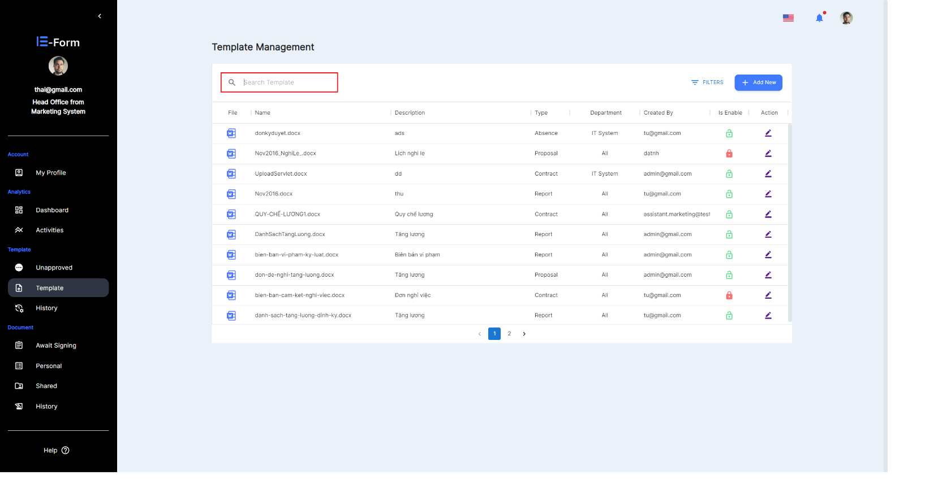

**Figure 47. Enter keywords template**

* After entering a keyword, the system will automatically search for templates with names related to that character.

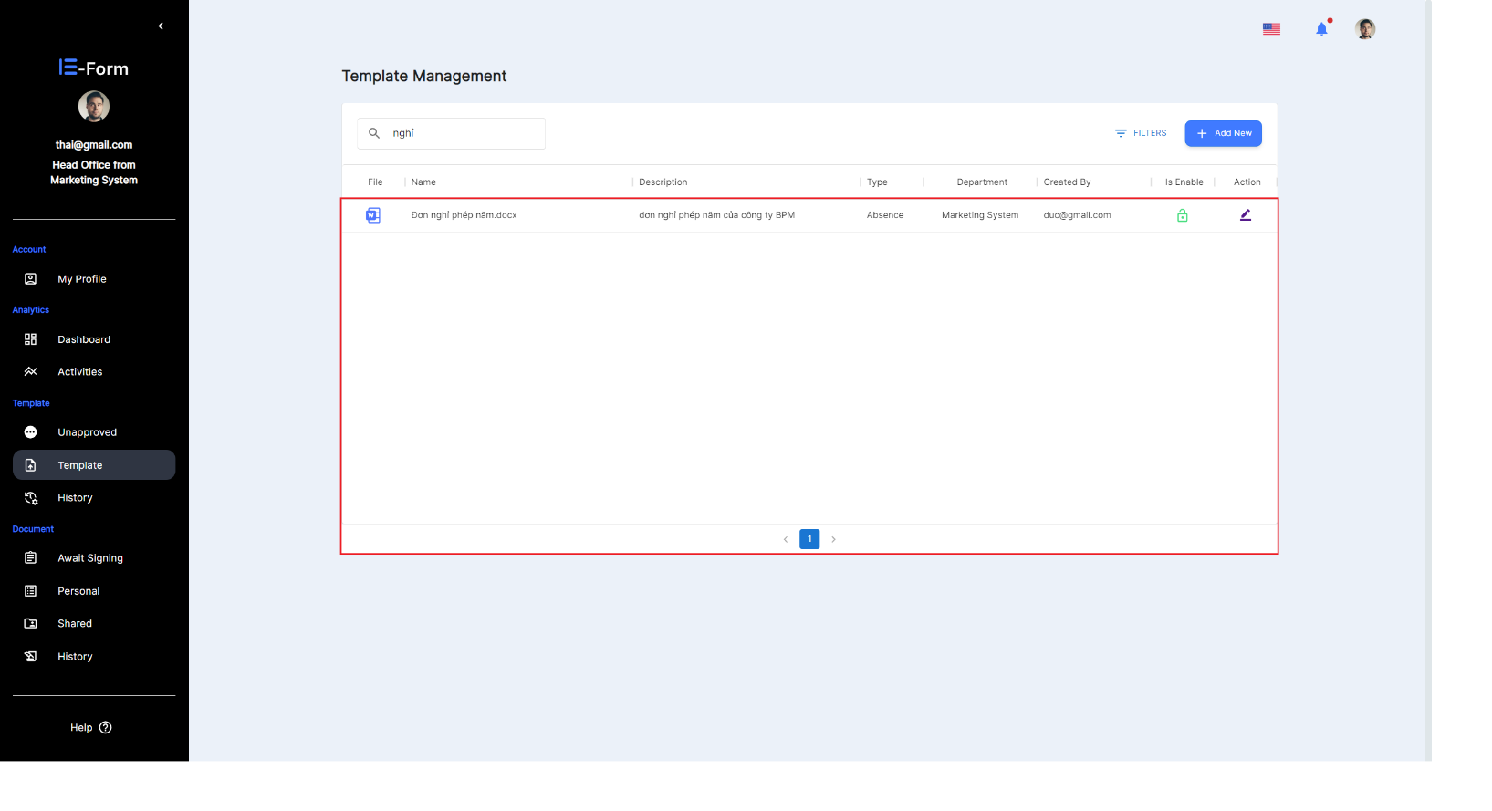

**Figure 48. Template found successfully**

## Document Management

### **Await Signing document.**

1. Select  on the website interface.

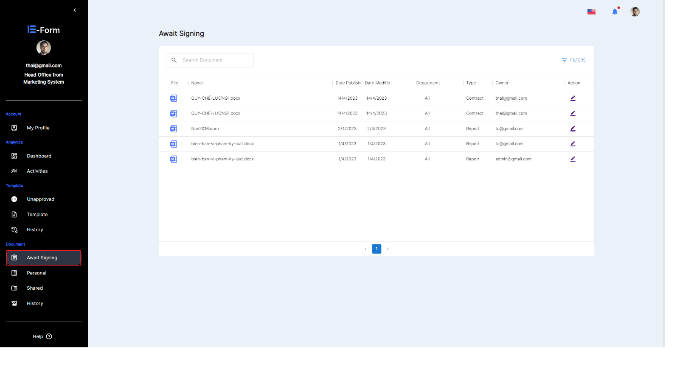

**Figure 49. Show the list of Await Signing**

1. In the action column, select the icon  of the waiting document that users want to control

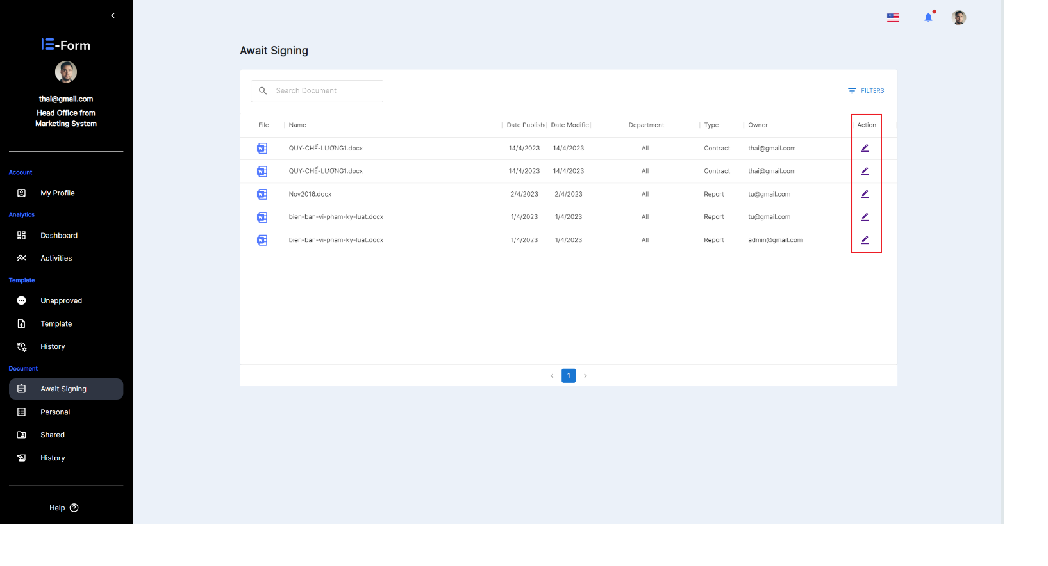

**Figure 50. View Await signing document**

1. At the Approve Document interface select Fill and Sign

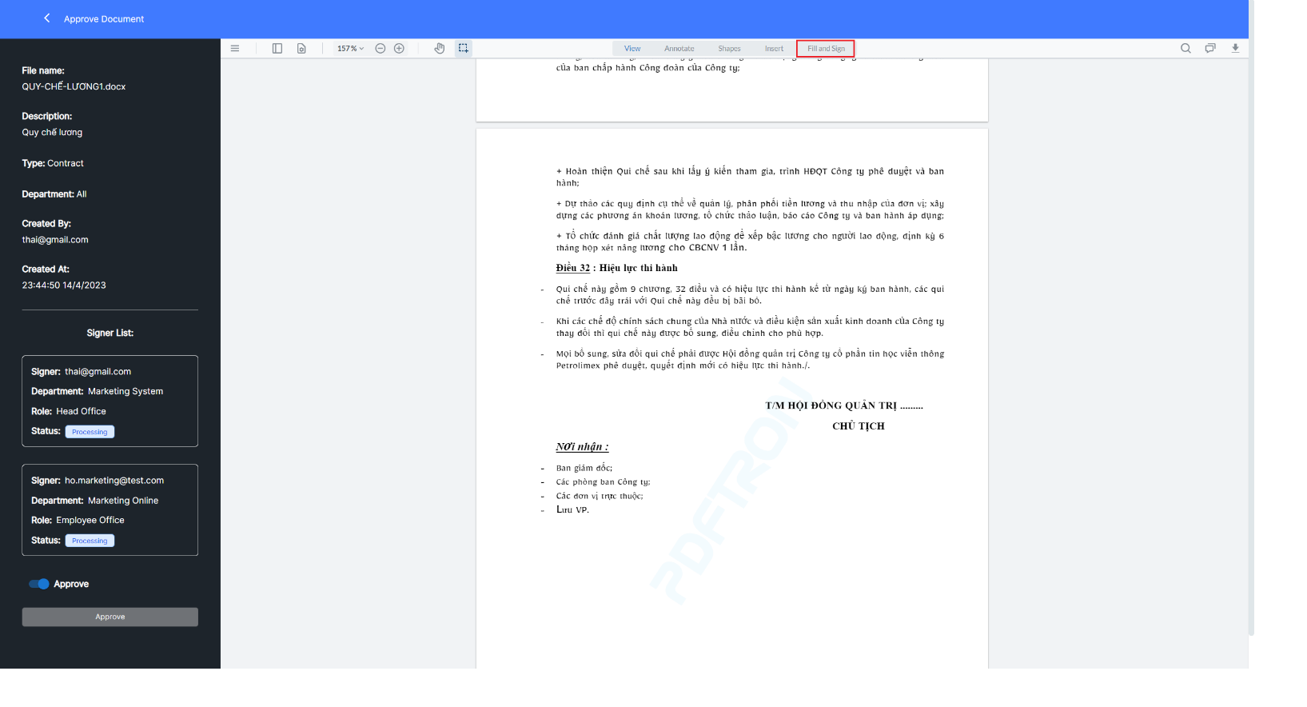

**Figure 51. Select fill and sign in Approve document**

1. Here the user will click twice: the first time clicks on the signature box, the second time clicks on the place to sign the document.

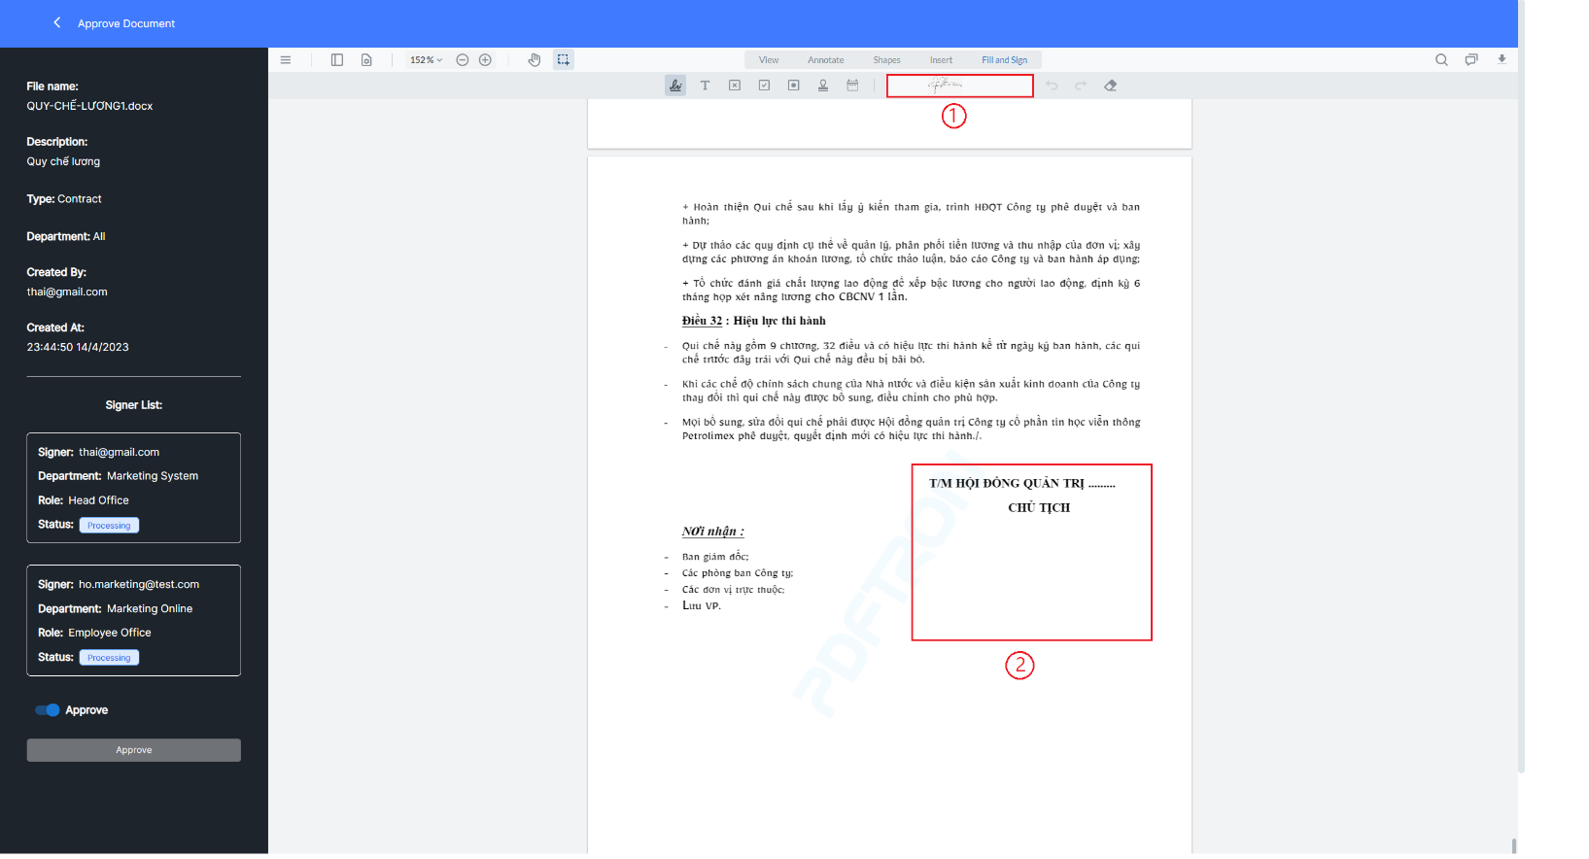

**Figure 52. Sign the application**

* 1. 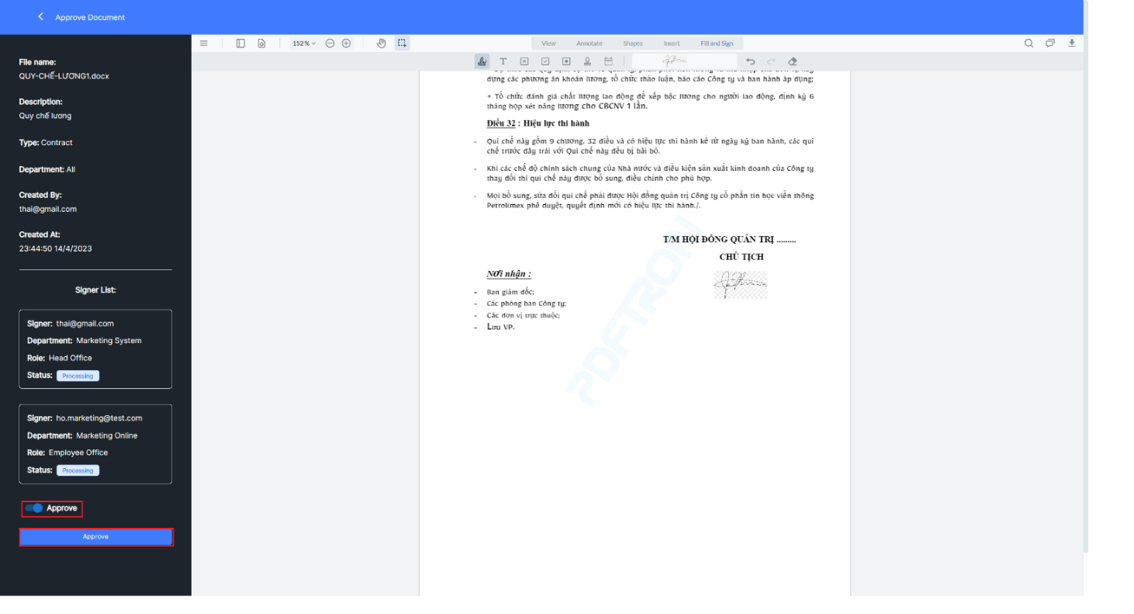When the status is  and the user select , then the user wants to sign.

**Figure 53. Perform document browsing**

1. When the status is , the user must enter the reason in the Reason box (), the system will display the  button for the user to click, when the user does not agree to sign the document.

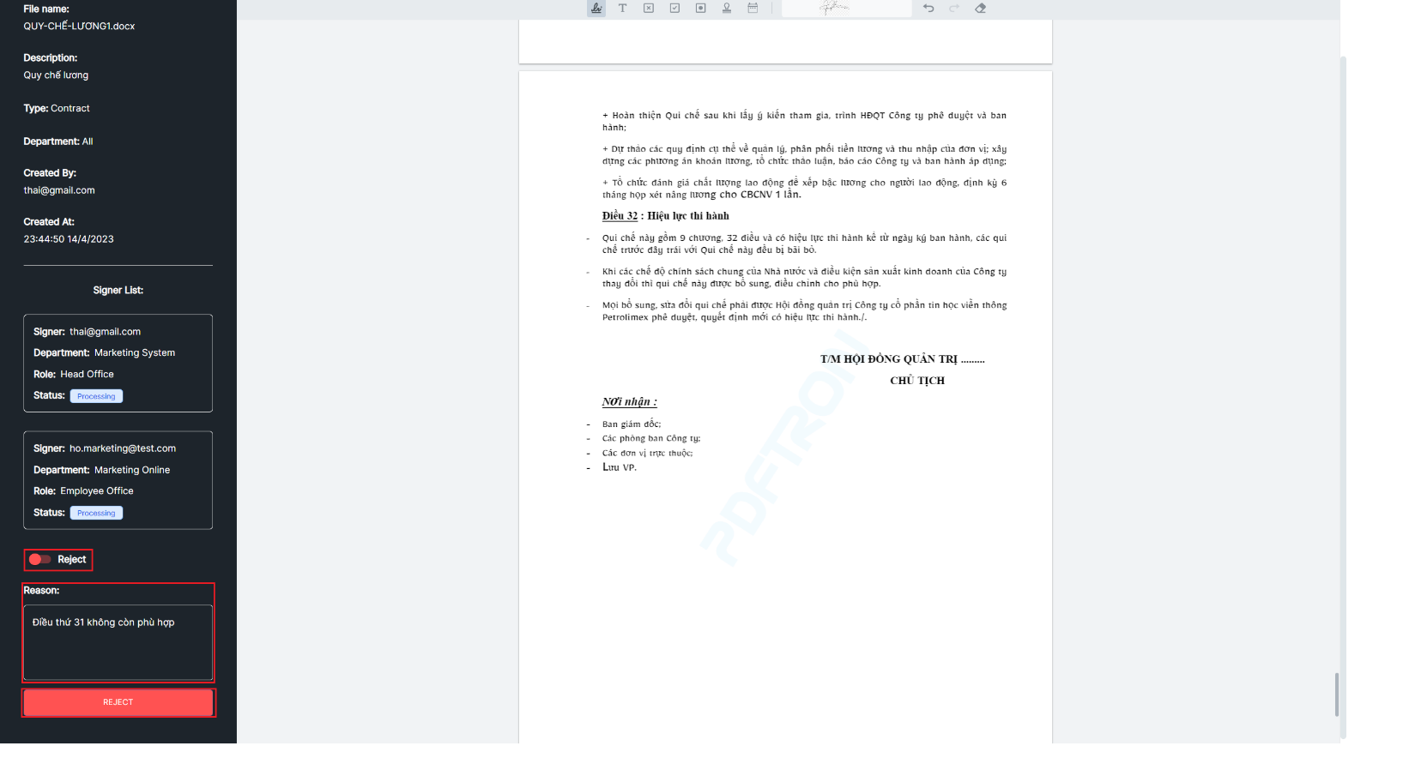

**Figure 54. Implement document rejection**

* 1. With the status is Approve, select  to approve the document or select to cancel and return to the approval document process.

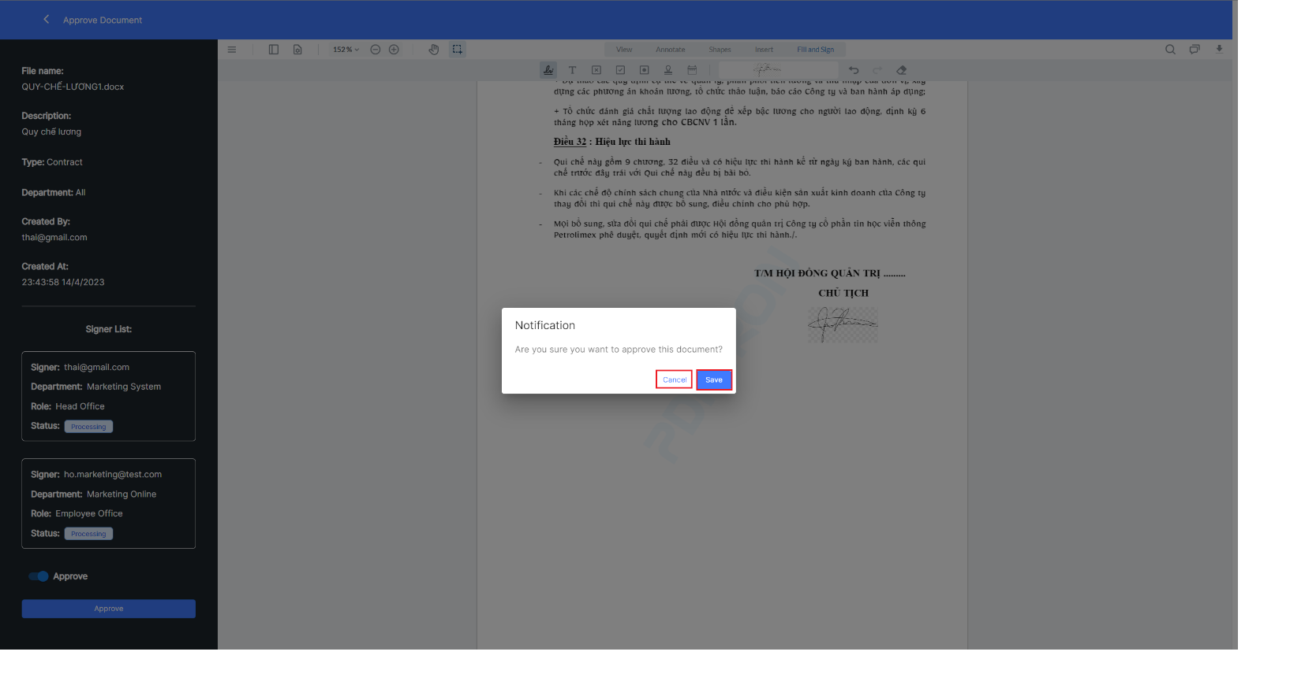

**Figure 55. Action notification when choosing document approval**

* 1. With the status is Reject, select  to reject the document or select to cancel and return to the approval document process.

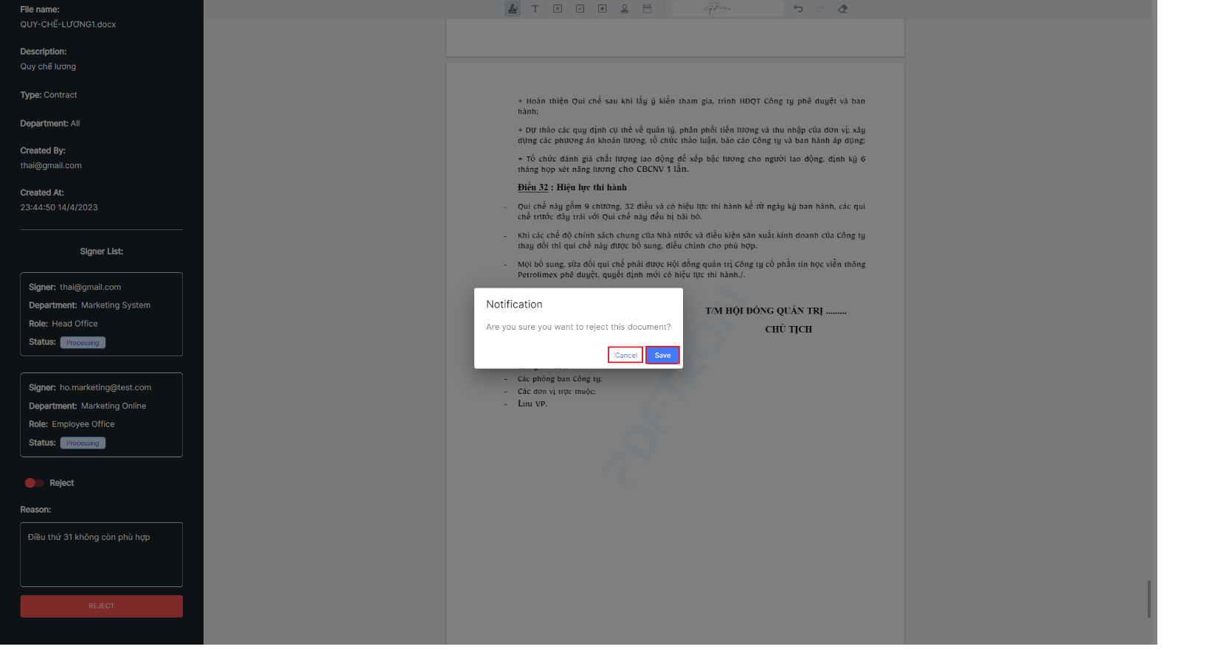

**Figure 56. Action notification when choosing to reject a document**

* Notification when accepting or rejecting documents successfully.

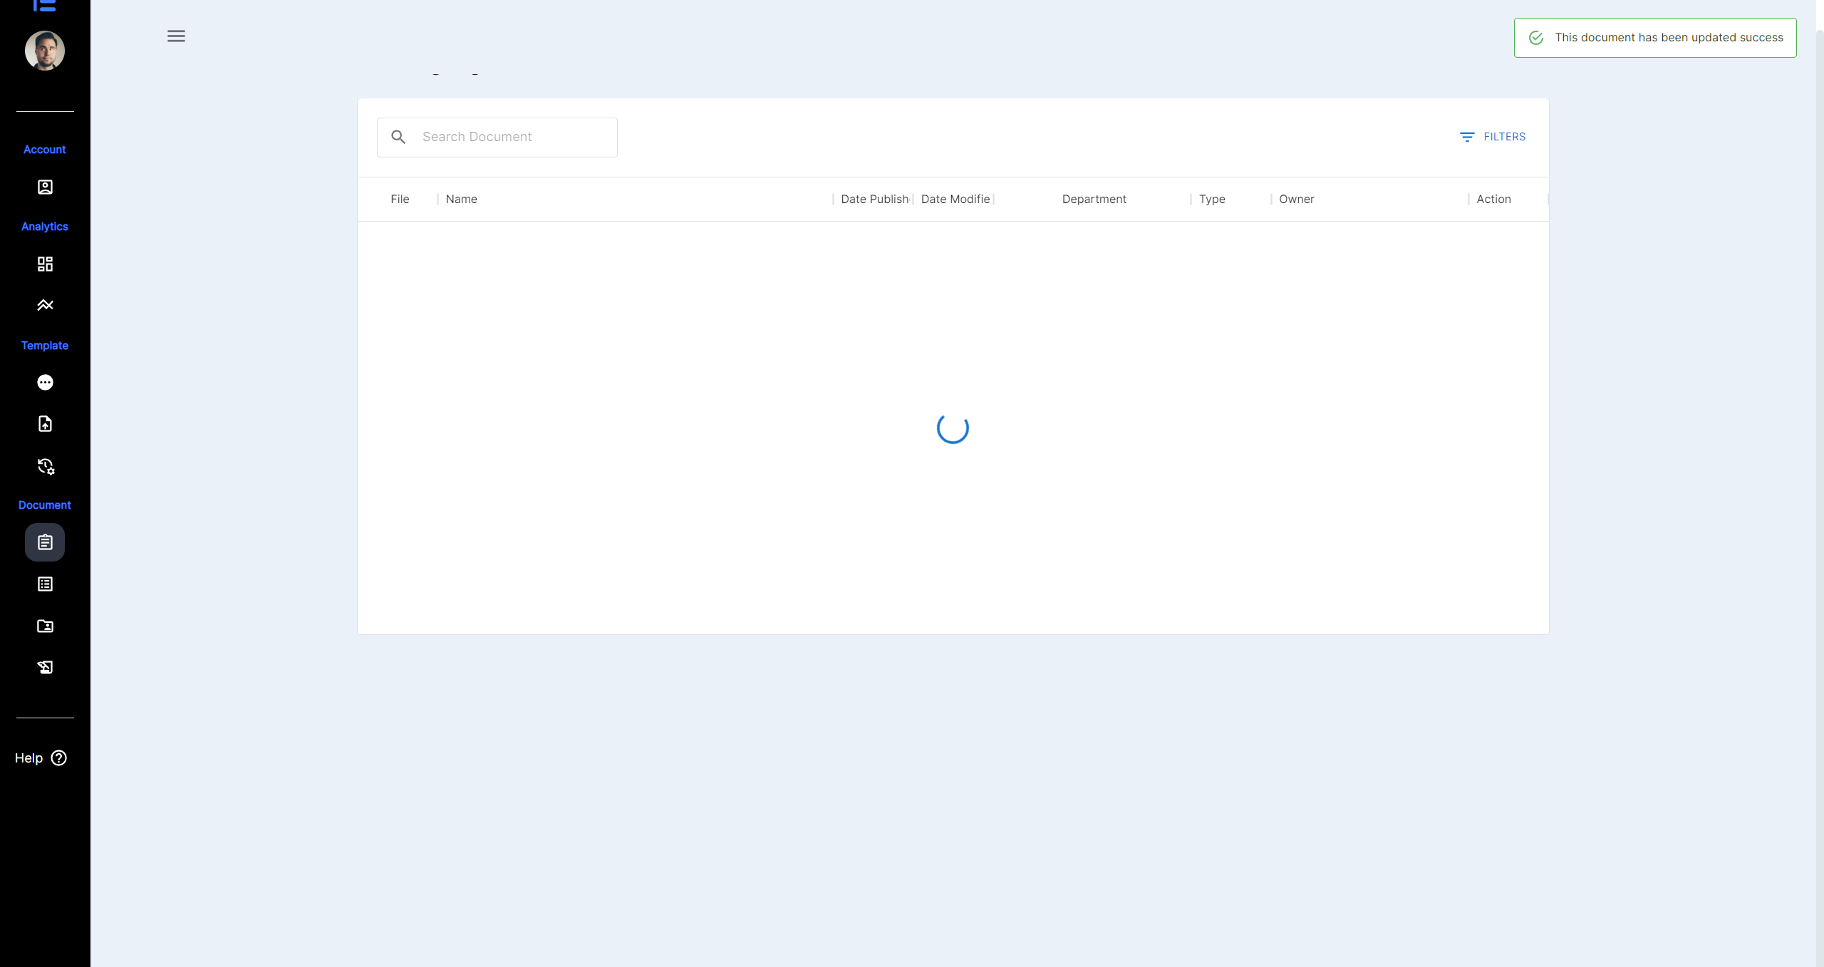

**Figure 57. Notice when accepting or rejecting document successfully**

### **View and search await signing document.**

1. Select  on the website interface.

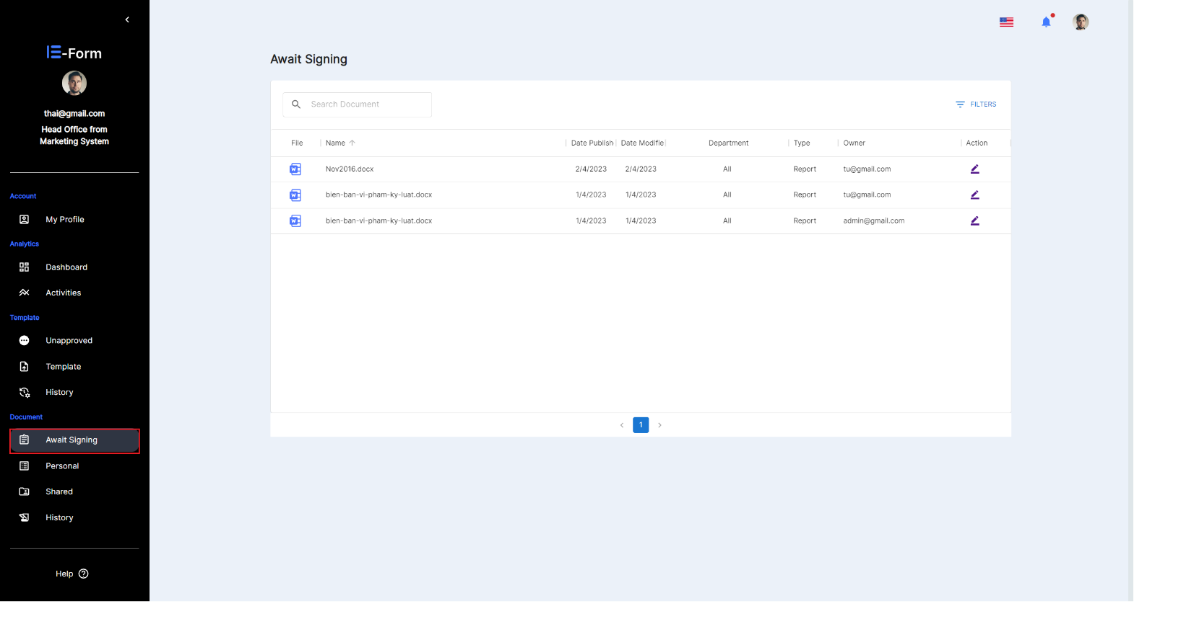

**Figure 58. View Await signing document**

1. Enter keywords in the search box.

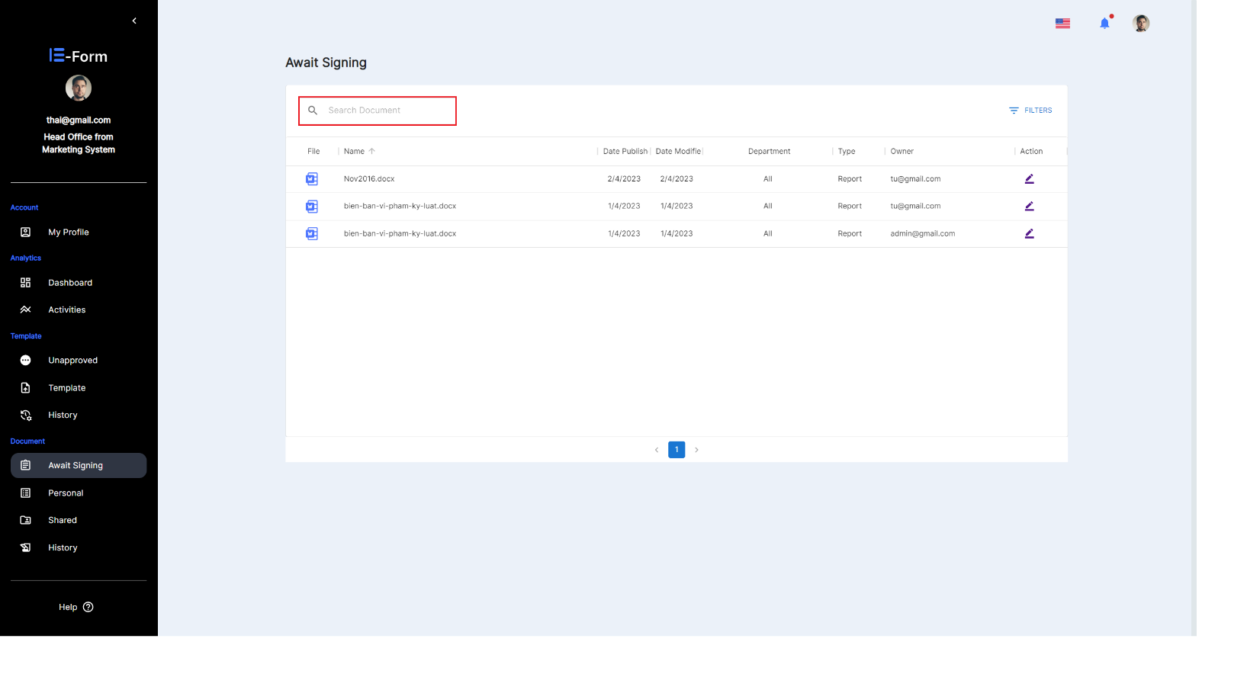

**Figure 59. Enter keywords**

* After entering a keyword, the system will automatically search for documents with names related to that character.

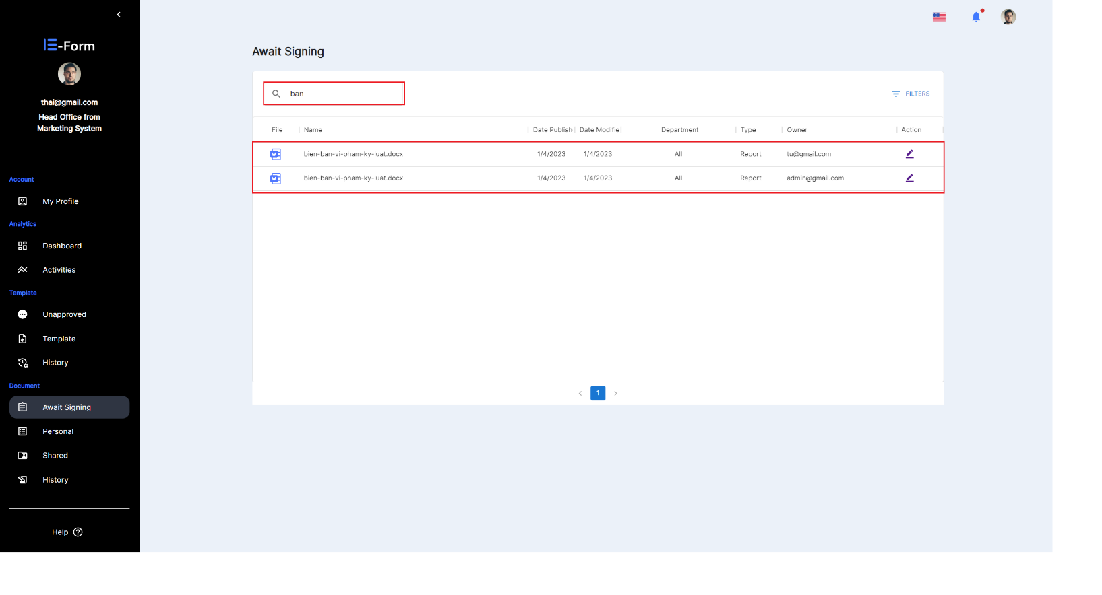

**Figure 60. View the list of documents after performing a search**

### **Personal document**

1. Select  on the website interface.

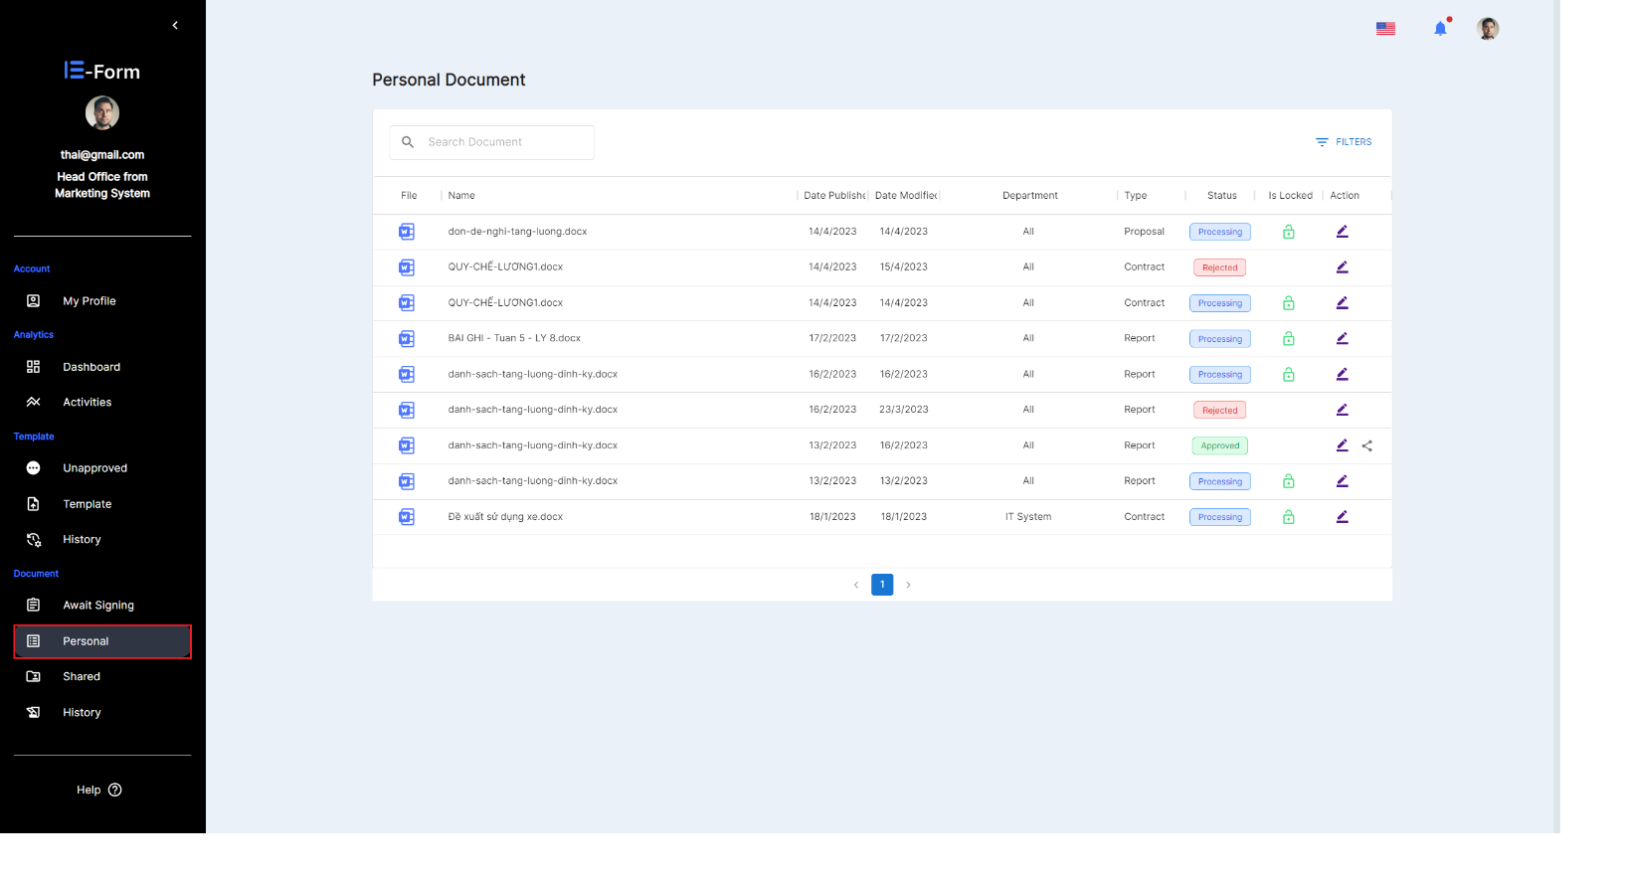

**Figure 61.** **Select personal function**

1. At the Actions column, select icon  in the document you want to view.

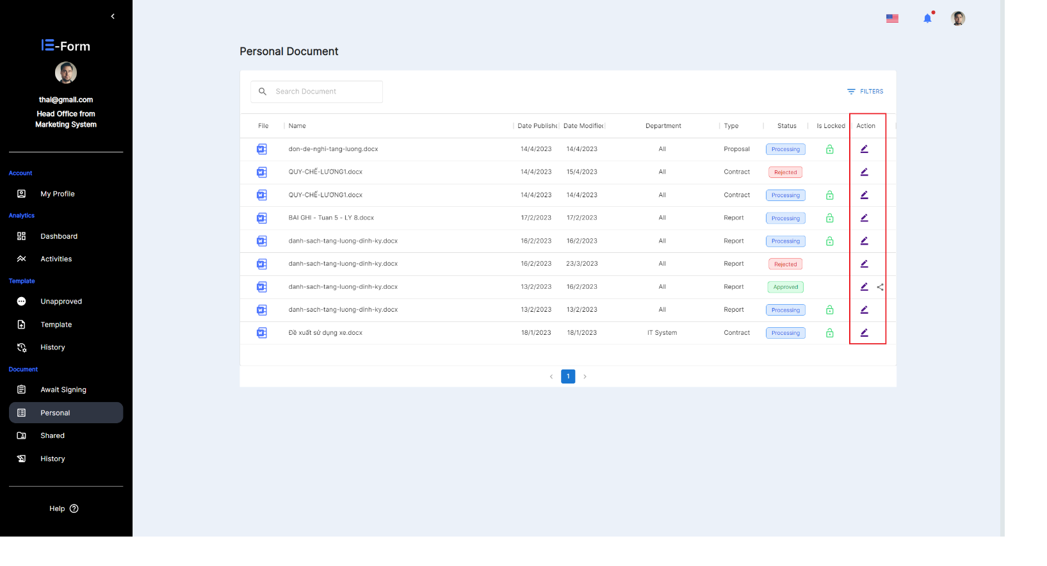

**Figure 62. Take action to view Personal Documents details**

* The system displays information, list of signers and document content.

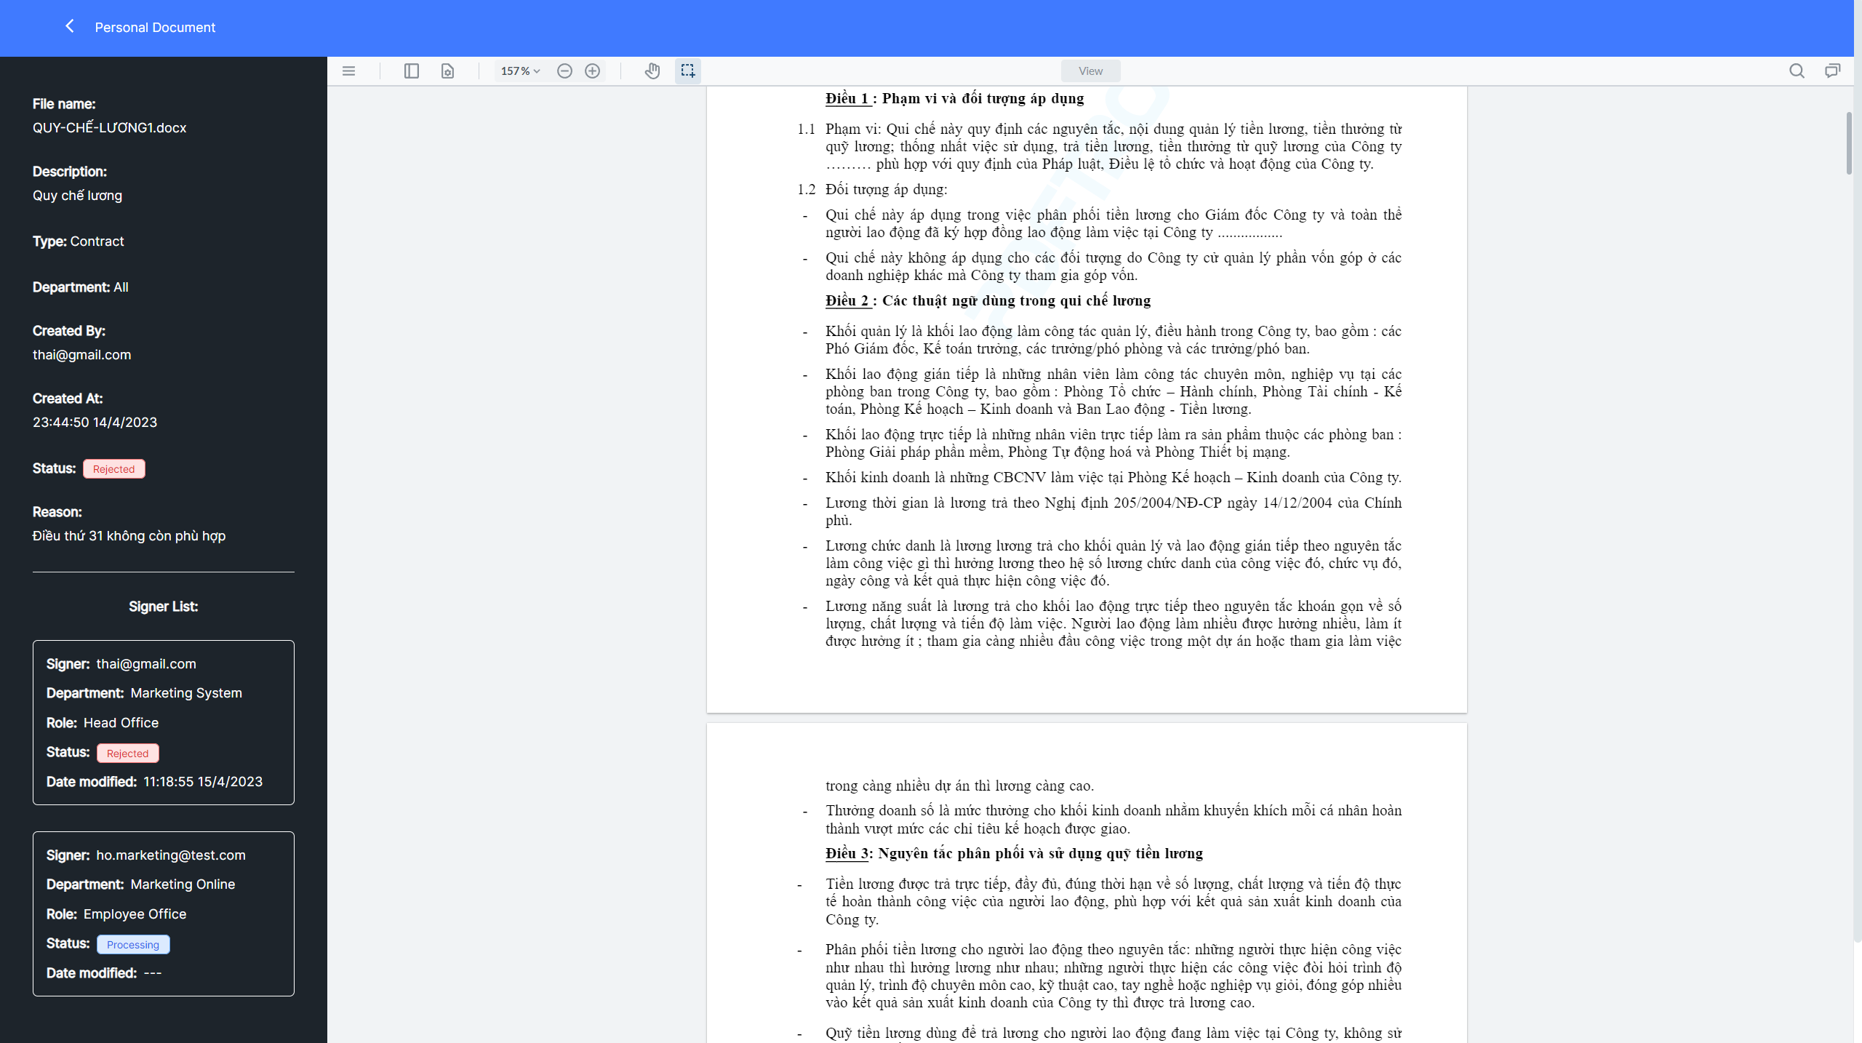

**Figure 63. Successfully view personal document details**

### **Lock/unlock personal document.**

1. Select  on the website interface.



**Figure 64. Implement the function of lock/unlock personal documents**

1. In the Is Locked column Select icon  to lock the document, select icon  to unlock the document.

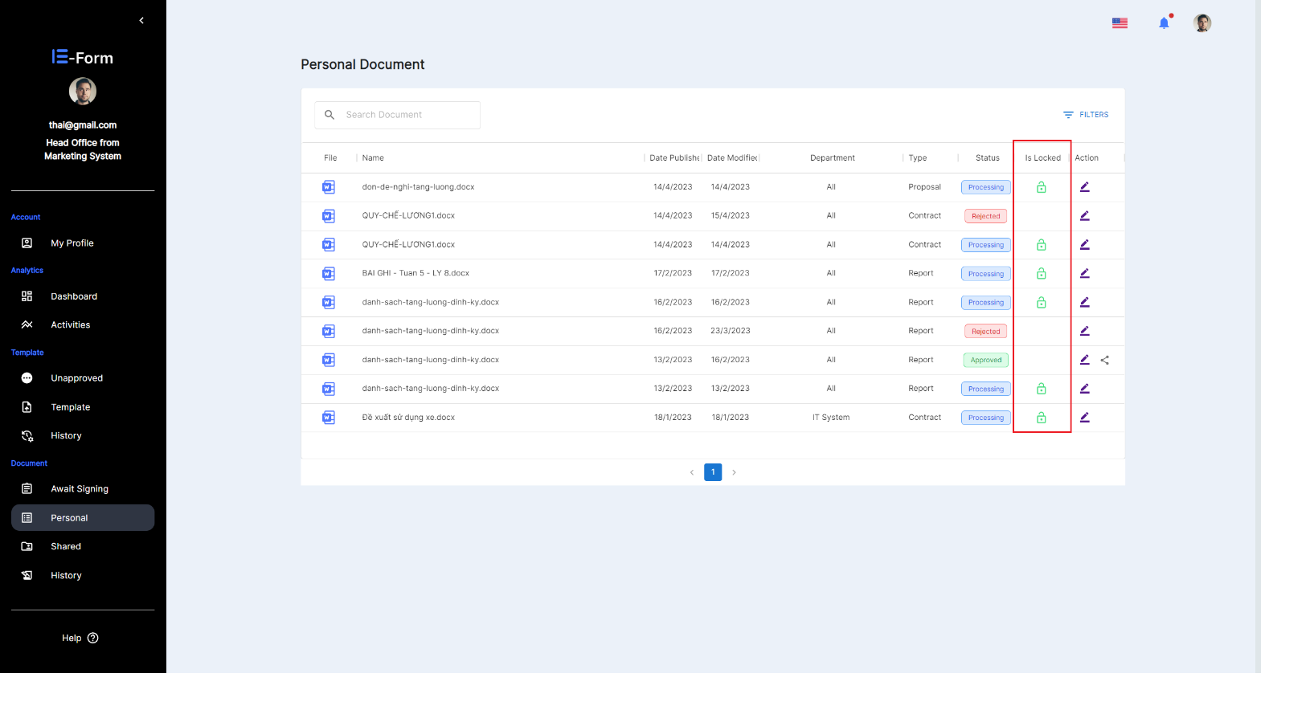

**Figure 65. Select the lock/unlock icon**

* Success message when changing document state from lock to unlock and vice versa.

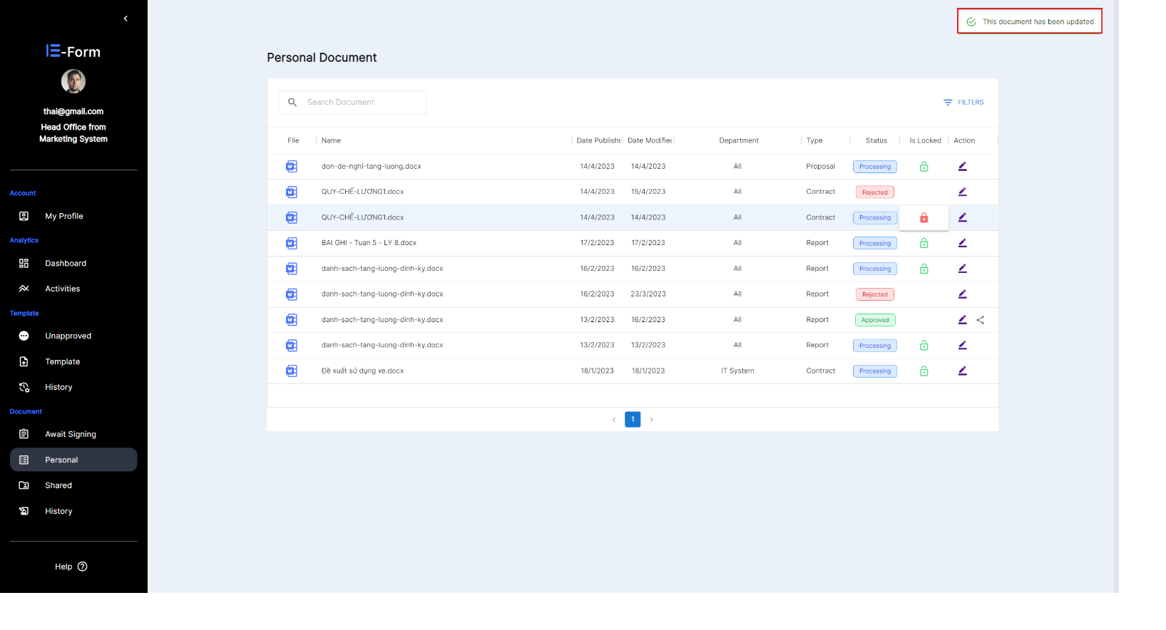

**Figure 66. View the message after successful locking/unlocking**

### **View and search for personal documents.**

1. Select  on the website interface.

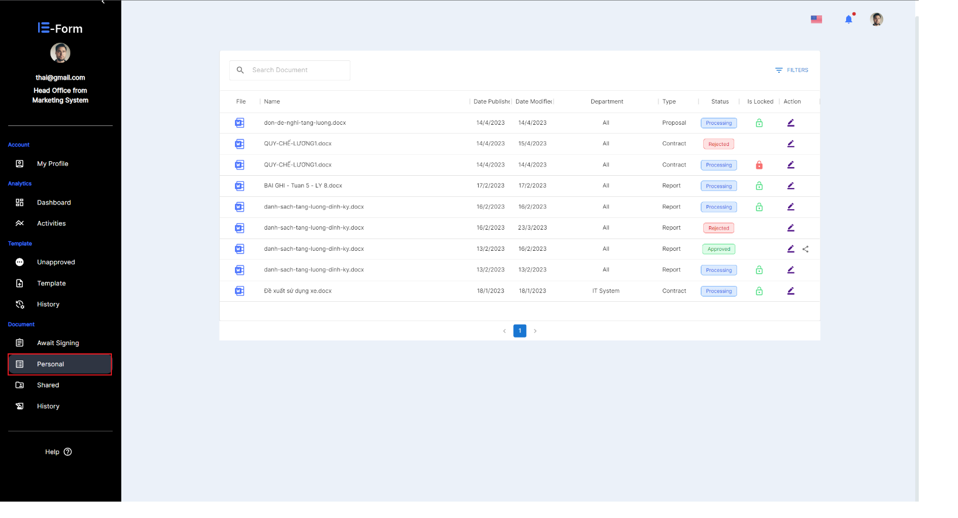

**Figure 67. Search personal document**

1. Enter keywords in the search box.

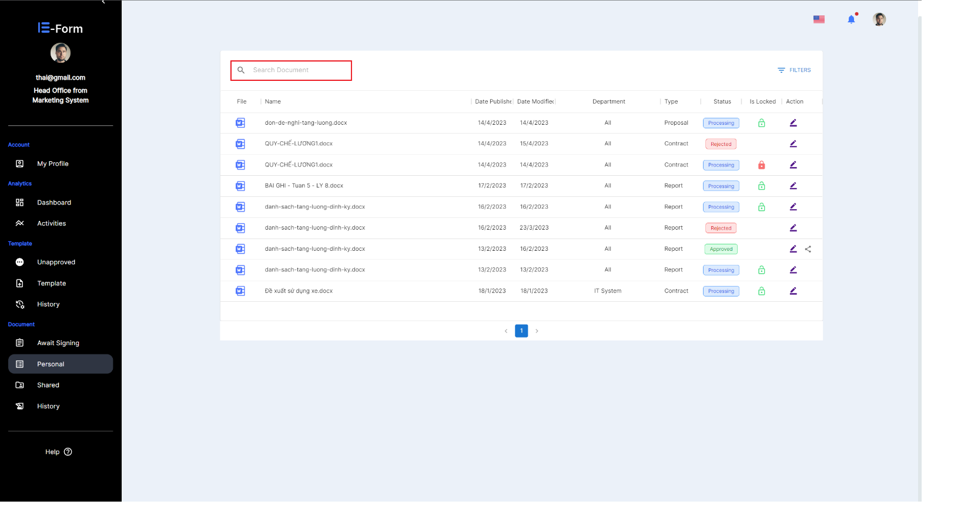

**Figure 68. Enter name of personal documents**

* After entering a keyword, the system will automatically search for document with names related to that character.

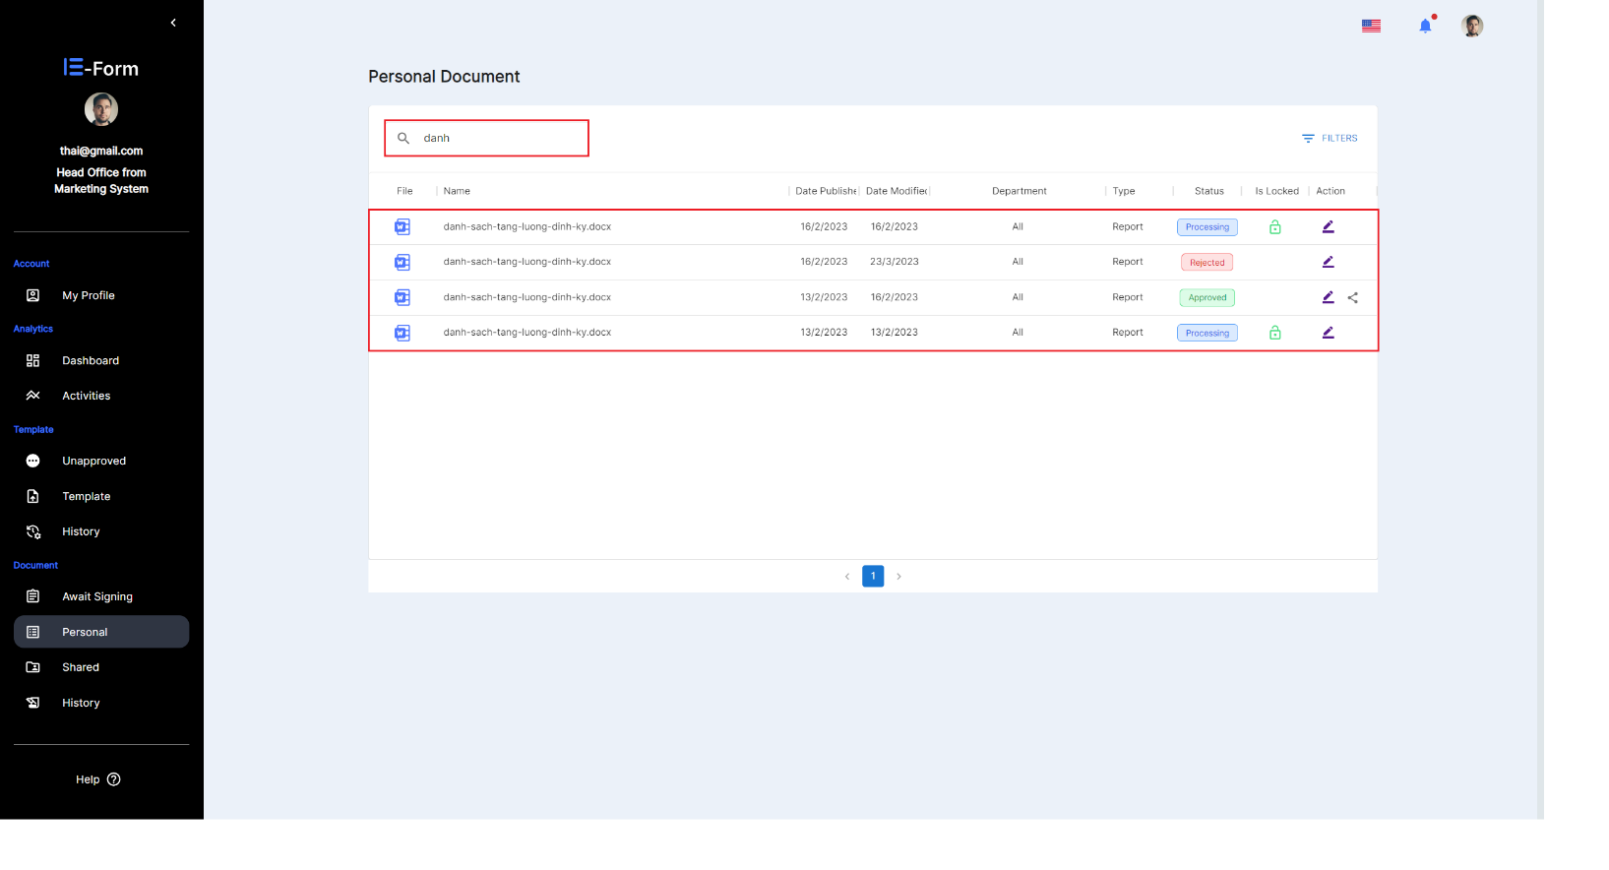

**Figure 69. Successfully search for personal documents**

### **Share document**

Note:

* The Share document function is only available when the document has been approved.
* Document sharing has 2 types: sharing for departments or for users.

#### **Share department**

1. Select  on the website interface.



**Figure 70. Use the document sharing function for department**

1. At the Actions column, select icon  in the document you want to share.



**Figure 71. Select Shared Document for department**

1. 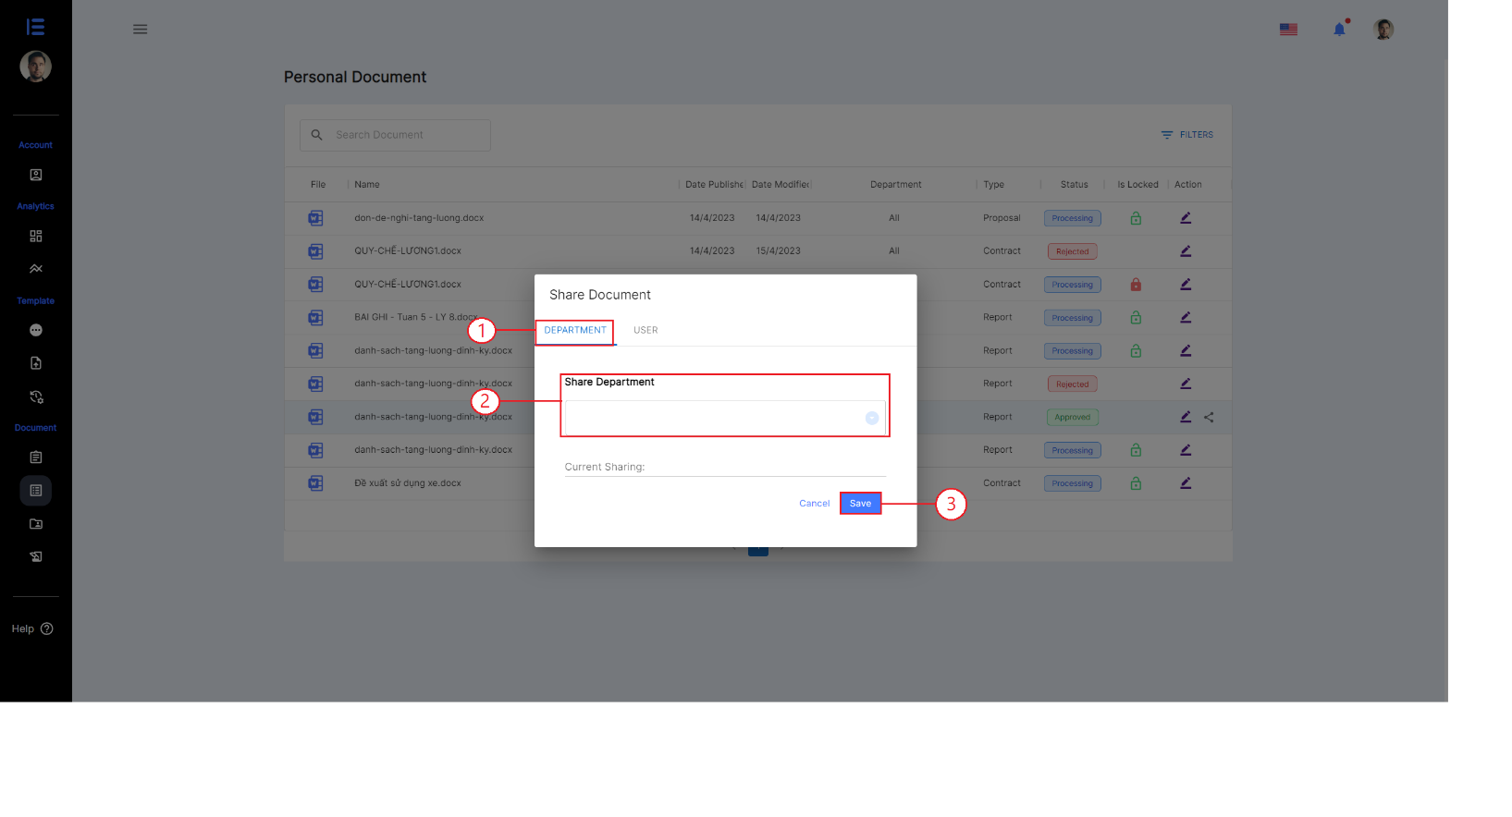Select item department (1), Then click on the List Box bar to display and select 1 or more departments in the List Box (2), Select the save button to complete the document sharing process (3).

**Figure 72. Implement document sharing for department**

#### **Share user**

1. Select  on the website interface.



**Figure 73. Use the document sharing function for user**

1. At the Actions column, select icon  in the document you want to sharing.



**Figure 74. Select Shared Document for user**

1. Select item user (1), Then click on the List Box bar to display and select 1 or more departments in the List Box (2), Select the save button to complete the document sharing process (3).

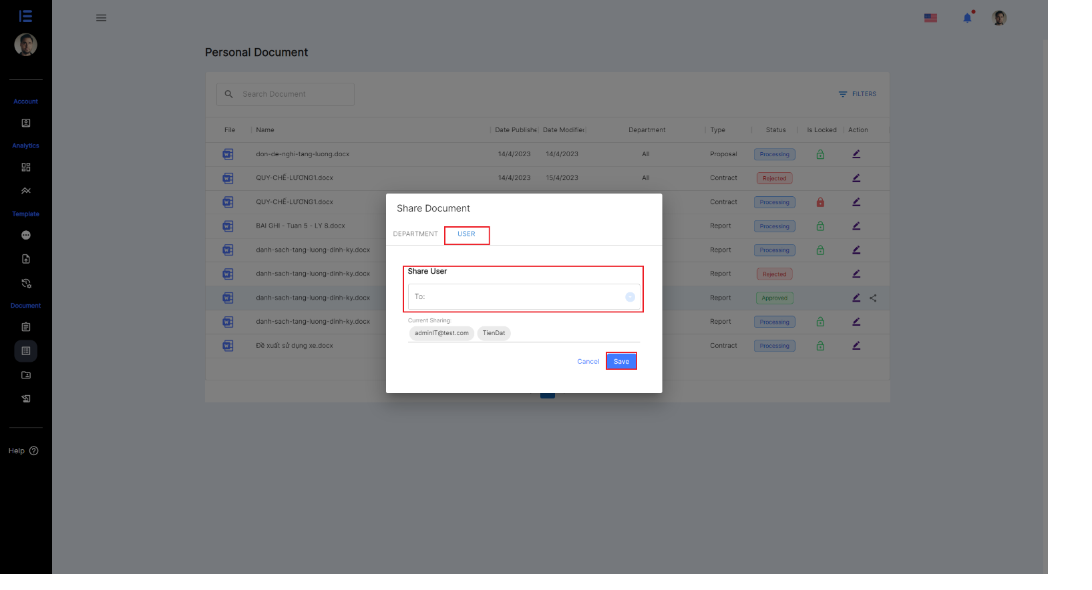

**Figure 75. Implement document sharing for user**

### **History document**

1. Select  on the website interface.

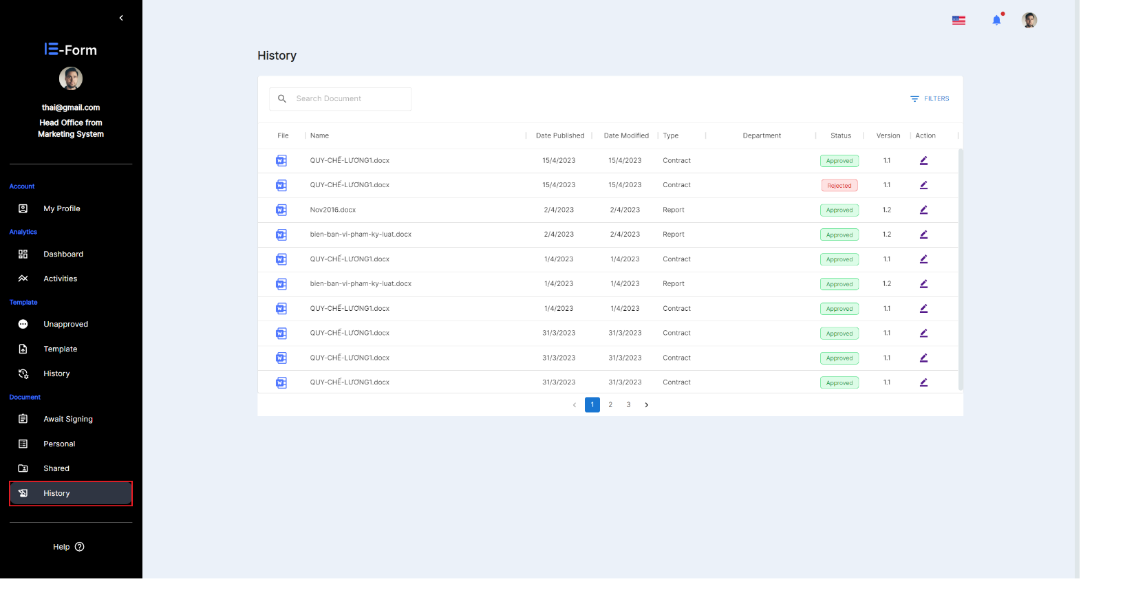

**Figure 76. Select history documents**

1. Select the ****icon in the Action column.

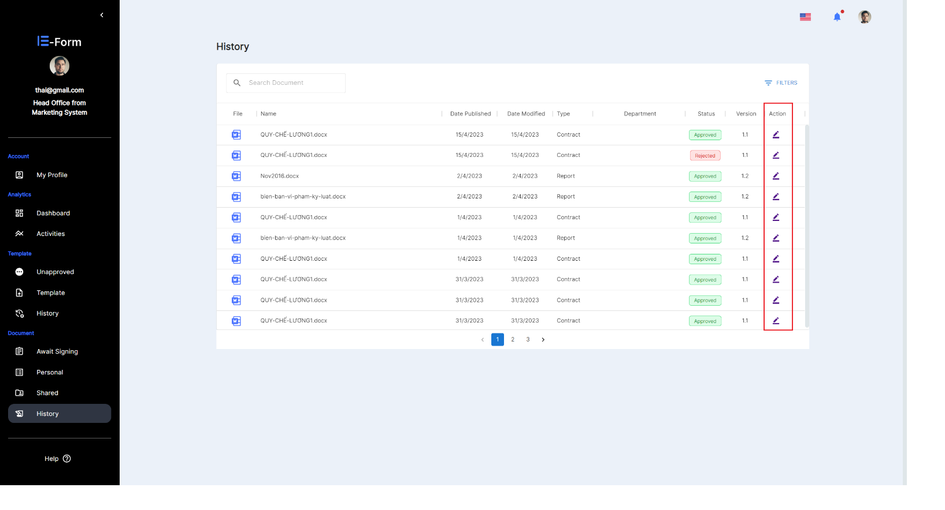

**Figure 77. Select document to view in history**

* View the history of the template was successful.

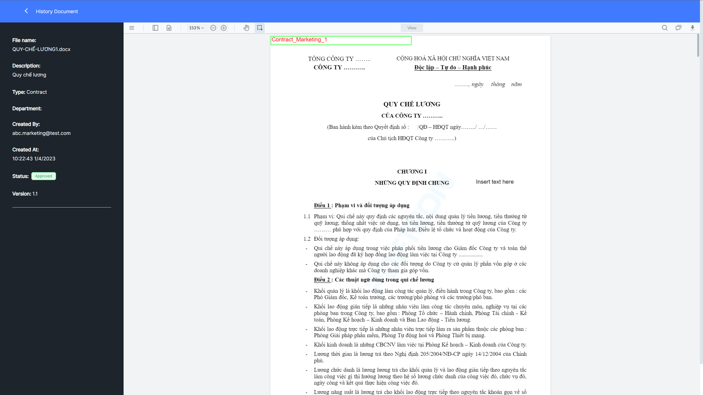

Figure 78. View the history of the document was successful

# Contact

-Gmail: eformvlu@gmail.com